EECS Senior Design



UC the Fish: Aquarium Submarine

Final Design Report

Date: 13/04/2016

University of Cincinnati, Ohio

UNIVERSITY OF CINCINNATI

SCHOOL OF ELECTRONICS & COMPUTING SYSTEMS

SENIOR DESIGN FINAL TECHNICAL DESIGN REPORT

Prepared By:

|  |  |
| --- | --- |
| Chelsea L Duran  Electrical Engineering |  |
| Ben M Lorenzetti  Electrical Engineering |  |
| Joshua L Alexander  Electrical Engineering |  |
| Zachary L Grbach  Electrical Engineering |  |
|  |  |



1. **Executive Summary**

Communication systems are everywhere today. It is hard to think of a technology that does not have some sort of communication system embedded within it. We transmit data through the skies, the walls of our cars, and even space. However, we do not need to look into space to find an area where communication systems are lacking. High-speed, wireless communication through water is extremely difficult because most electromagnetic waves attenuate quickly in this medium. This is significant since we live on a planet that is mostly covered by water. A high-speed, underwater communication system is important to not only benefit from and utilize our environment, but to also maintain and protect it.

The goal of this report is to show a design process and resulting prototype that attempts to explore aspects of communicating in a historically difficult medium. This is done using the concept of an aquarium submarine. Centering this project in an aquarium environment allows us control certain parameters that would otherwise be variable in an oceanic environment. It creates a closed system where difficult issues can steadily arise rather than swamp the progress of building such a device. However, it will still leave the basic, obstructing factors of oceanic communication untouched. The main submarine attributes are control of device and motion of device. These attributes were achieved through purchasing an open-source, underwater drone called the OpenROV. However, this device uses a tether to communicate with land.

As this report will describe, we designed an optical communication system between the aquarium submarine and land. A transmitter board accepts an Ethernet line as an input and converts it into an optical signal via LEDs. This optical signal is then captured using photodiodes and retranslated to an electrical signal using a receiver board. The system attempts to effectively replace a standard Ethernet connection with two optical boards that act as a wireless link between two devices using only analog circuitry. Instilled in the aquarium submarine, the communication system will allow the submarine to move untethered transmitting data wirelessly to and from land.

This communication system is designed in such a way that allows the entire system to be easily deployed into other applications. The communication system is modular and compatible with any Ethernet device. This encourages using this project to expand into a variety of fields and applications.

1. **Background**

Approximately 70% of the earth’s surface is comprised of bodies of water, including lakes, rivers, and oceans. In the 46 public aquariums across the world, people have the opportunity to admire and learn about the ecosystems contained in these bodies of water. The Association of Zoos and Aquariums surveyed nine of the top aquariums in the US and found that an average of 16 million people visit per year. Within museums, science centers, zoos, and aquariums, interactive exhibits have been found to be highly attractive for visitors (Sandifer, 2003) and--if designed correctly--can increase educational success (Allen, 2004). However, many aquarium exhibits offer little interactivity and have blind spots obscured by terrain features. A user controlled submarine with video streaming could address both of these issues.

Such a submarine would also fit nicely with three other trends in aquarium exhibit interpretation identified by the Oregon Coast Aquarium:

1. “Offering a ‘Wow’ factor as a better hook.”
2. “Shift from single-user interactions to a greater use of those that can engage the whole family.” (Separation of depth, horizontal, and video controls; identification missions; etc.)
3. “Using web-based connections...to...stay connected with people after they leave the institution.”

A current example of the third trend is the *Live Diver* (<http://www.livediver.com/>) from the Aquarium of Boise, which is a website that allows people to take control of a submarine in an exhibit and explore the tank. However, the *Live Diver* video is not in color and has significant lag, and the submarine is hard to maneuver. Other aquariums have webcams within the tank streaming a live feed to a website. Unfortunately, these webcams are often stationary or have limited motion. The few commercial underwater devices with cameras with live video feed are not designed to be operated inside of an aquarium.

In order to solve this problem, we proposed a waterproof vessel that will have camera capabilities to stream live video optically though water. It will have motors, a hydrofoil shape, and sensors so that it may both hover in place and move as desired. The video data will be transmitted to a server, either wirelessly or by data cable to an antenna buoy. Land side, a user will be able to supply commands to maneuver the vessel. The device will be fish-friendly and not damage the aquarium environment.

1. **Design Process**

This project began by brainstorming a list of attributes for the device.  Survey and interview questions were created from this list, and given to aquarium curators and hobbyists. The hobbyists ranked the attributes based on significance. The highest ranked attributes were wireless communication (4 out of 5), live video streaming (4.33 out of 5), and remote-controlled motion (4.44 out of 5). During an interview, the Zoological Operations Manager at the Newport Aquarium, Jeff Gibula, agreed with the importance of wireless communication. However, he requested that the submarine have a set path to follow. In addition, he would like to focus on using the submarine for educational purposes.  Based on those results, the list of brainstormed attributes was edited. The final pruned list of objectives is shown below:

* 1. The submarine should be **safe**.
     1. The submarine should be fish safe.
     2. The submarine should be environmentally safe.
  2. The submarine should be **operational**.
     1. The submarine’s motion should be able to be controlled.
     2. The submarine should be able to stream video.
        1. High quality video
        2. Adequate frames per second
     3. The submarine should be untethered (wireless).
        1. Water depth and salinity will affect transmission
     4. The submarine should be able to monitor its aquatic environment.
     5. The submarine should be able to capture still photos.
  3. The submarine should be **durable**.
     1. The submarine should resist salt corrosion.
     2. The submarine should have proper lubrication for mechanical components.
     3. The submarine should withstand water pressure.
  4. The submarine should be **usable**.
     1. The submarine should have easy maintenance.
        1. The submarine’s camera optics should stay free of debris.
     2. The submarine should have a user interface.
        1. The submarine should be educational.
           1. Have fish facts
           2. Identify fish
     3. The submarine should have fail safes in place.
     4. The submarine should be able to operate in open waters as well as aquariums.

Based on these objectives, we generated related constraints. Constraints are project attributes that must be present in our final project. We created a pruned objective and constraints tree shown in Figure 3.1.

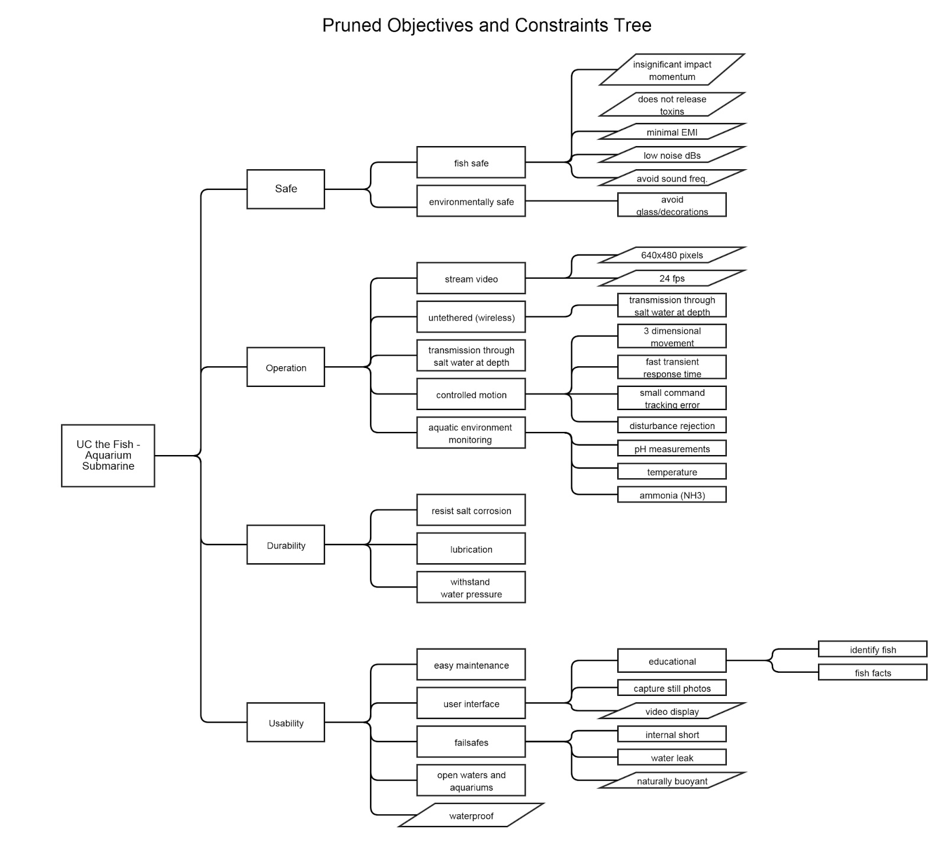

**Figure 3.1: Tree of Objectives (Rectangle) and Constraints (Parallelogram)**

The four main categories of objectives are safe, operational, durable, and usable. A ranking of these objectives are shown in Table 3.1. Safety is ranked highest, because the curators and hobbyists agreed that they would not use the submarine if it damages their tanks or hurt the fish. Operational is the second most important objective, because the customers want a device that will stream live video and have motion control. Durable and usable are tied as third important.

|  |  |  |  |  |  |
| --- | --- | --- | --- | --- | --- |
|  | Safe | Operational | Durable | Usable | TOTAL |
| Safe | X | 1 | 1 | 1 | 3 |
| Operational | 0 | X | 1 | 1 | 2 |
| Durable | 0 | 0 | X | 0.5 | 0.5 |
| Usable | 0 | 0 | 0.5 | X | 0.5 |

**Table 3.1: Pairwise Comparison of Main Objectives**

Each of the subcategories of objectives was ranked as well by analyzing the voice of customer response. In the category of safety, the device should not hurt the fish or damage the environment. In the category of operational, the most important objective is streaming video, followed closely by motion control. Both of these operations are the basic purposes of the device. The hobbyists tended to want remote control, while the aquarium curator would like the submarine to move along a set path. Monitoring the aquatic environment and still photo capture are the least important operational objectives.  When considering the durability of the device, its ability to withstand water pressure is the most important, since this will have the largest effect on the operation of the device. When analyzing the usability objectives, the customers agreed that a user interface is necessary. They also requested that the device be easy to maintain and have fail safes to protect the fish and environment.

After ranking our objectives, the voice of customer data was used to determine our project’s major functional components. Control and motion of the submarine were determined to be crucial functionality, and are considered the top two functions. This entails everything from what type of raw input controls are handled in the system (i.e. rotational and linear propulsions) to how the submarine is able to move through space (i.e. dimensions of movement and hydrodynamic components of submarine). We came to this conclusion after seeing a pattern of responses from potential customers voicing the need for both ease of motion and control of the submarine in our surveys. Additionally, Mark Bolander, the creator of another remote-controlled submarine device, continually expressed his concern of current drifts affecting control and the density of water causing particular issues with movement. In our correspondence with Mark, he talked about these issues with control and motion translating to frustration from the user of the submarine. To show the functionality and interactions of functions, transparent boxes and functional means trees for control and motion were created which are shown in Figure 3.2, Figure 3.3, and Figure 3.4.

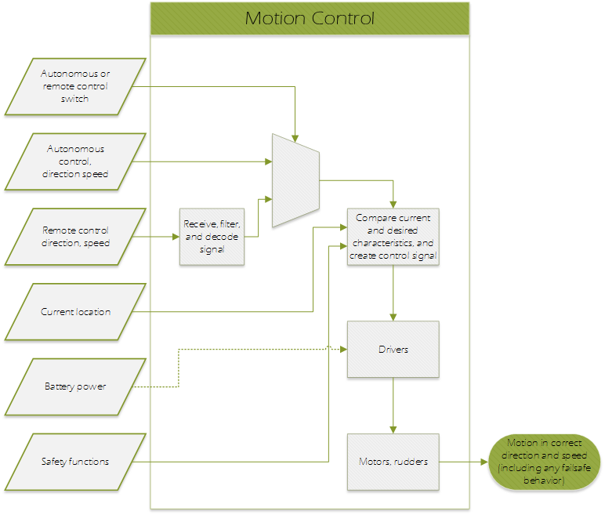**Figure 3.2: Transparent box for submarine control and motion**

***Note****: Control and motion are combined here since control and motion function interactions are very closely related (control results in motion).*

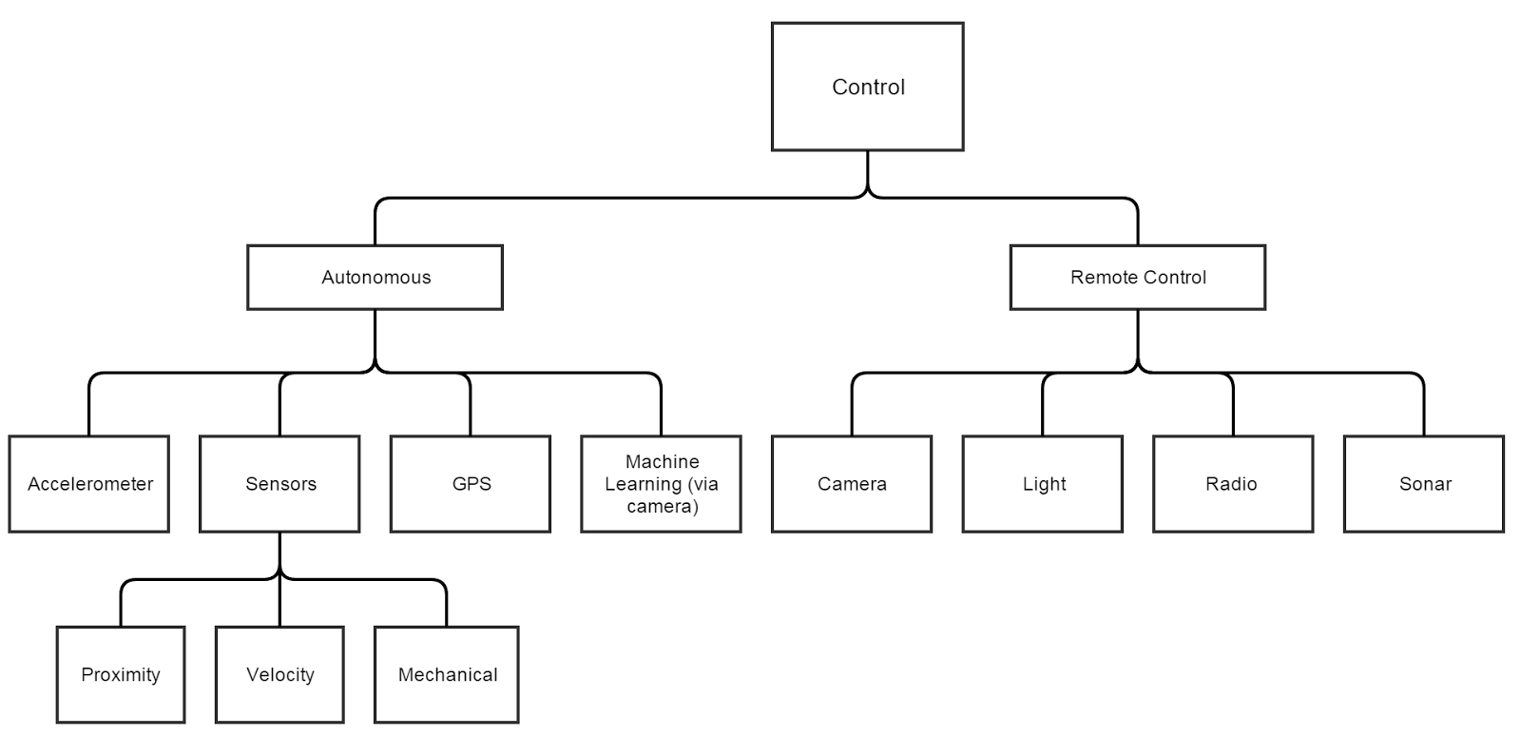

**Figure 3.3: Functional-means tree for submarine control**

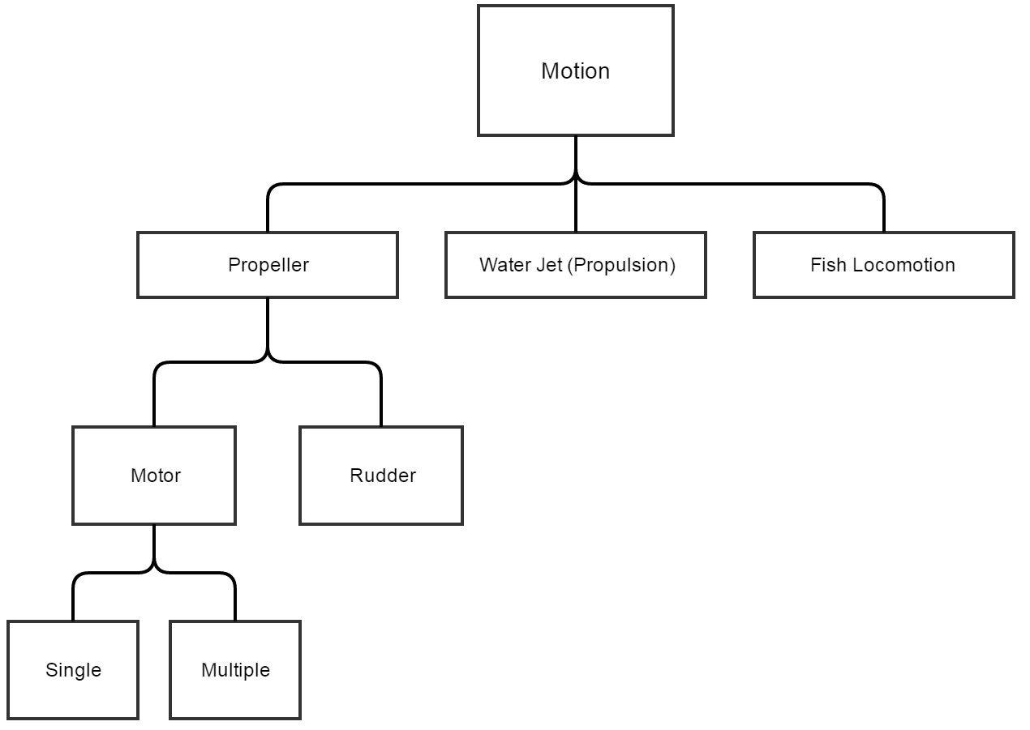

**Figure 3.4: Functional-means tree for submarine motion**

The next group of related functional components of the submarine deals with communication of the submarine. It was decided that the ability to stream live data to and from the submarine is of top importance. This decision was translated after seeing a recurring theme from the surveys for a large desire for live streaming. This function is also related to one of our submarine’s stand-out characteristics, wireless communication under water. To show the functionality and interactions of functions, transparent boxes and functional-means trees for live streaming were created which are shown in Figure 3.5, Figure 3.6, and Figure 3.7.

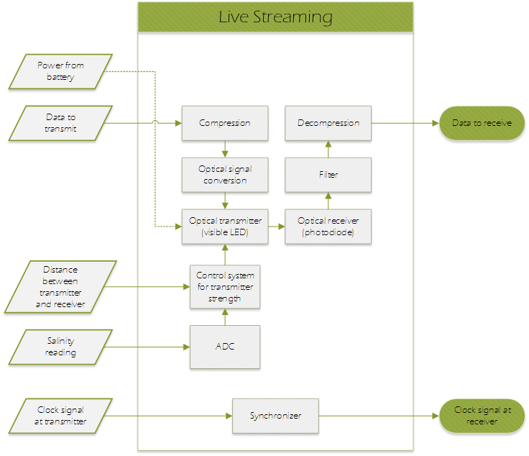

**Figure 3.5: Transparent box detailing live streaming functionality**

***Note****: A transparent box for live video streaming is not included as it is encompassed by this live streaming transparent box where the data is specifically video data.*

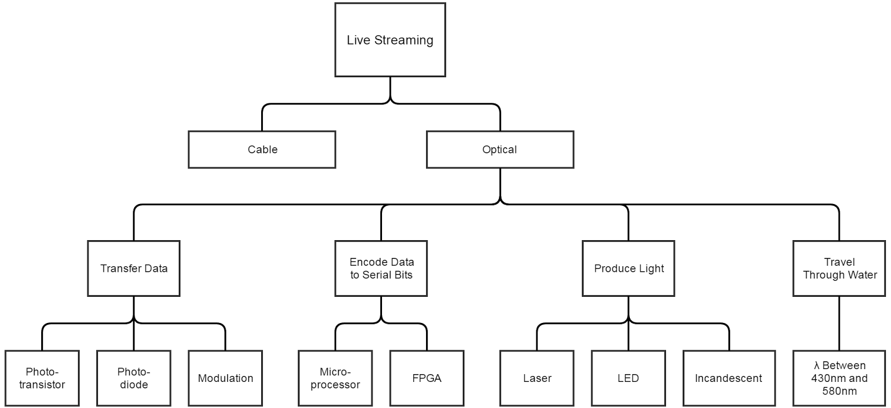

**Figure 3.6: Functional-means tree for live streaming functionality**

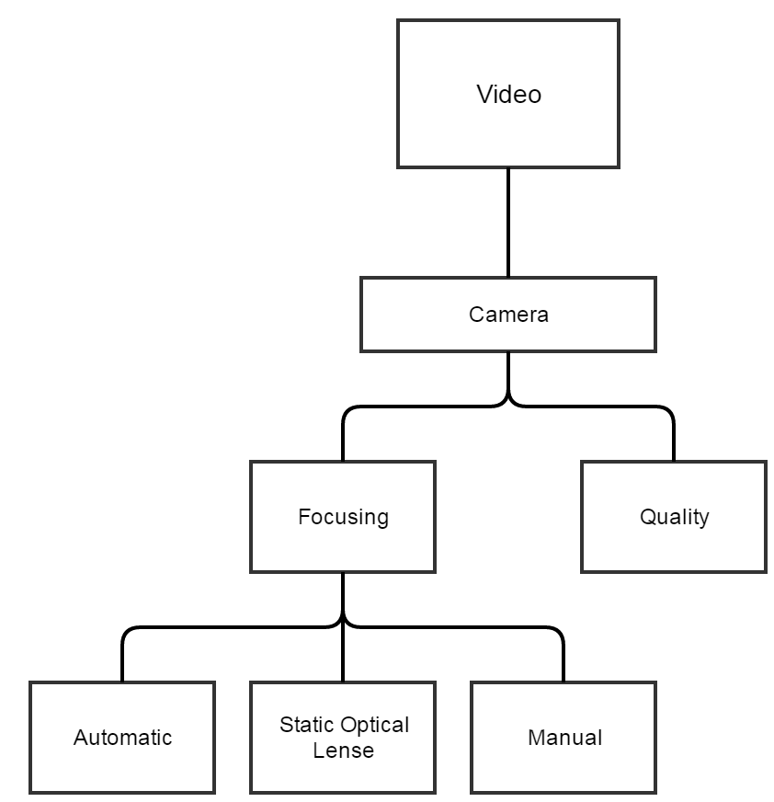

**Figure 3.7: Functional-means tree for live video streaming functionality**

The last group of functional components scored at the bottom end of the survey results and was decided to be least important but still major functional components of the project. These functional components are closely related to the user interface portion of the project. The user interface will entail its own feature subset itself. Some of the possible features of the user interface will include: video display, fish facts, fish identification, aquatic environment monitoring displays, and the control scheme presented to the user which will be translated to raw control inputs to the submarine. Two of these features, aquatic environment readings and fish facts, scored the lowest on our one-out-of-five feature survey rating. It is important to remember that some of these components are related to other functional components (i.e. video display and aquatic environment monitoring). Since live streaming encompasses the ability to stream signals, video signals will be able to be communicated from the submarine and presented to the user in the user interface. This is just a single example of how the paths of various functional components are so closely linked they almost seem to be overlapping.

After doing research into commercial available underwater drones, we found the OpenROV. The OpenROV is an open-source, waterproof drone, designed for educational purposes that is easily constructed and maintained.  The OpenROV was found to meet many of our project attributes and requirements. Table 3.2 shows which objectives the OpenROV would met.

|  |  |
| --- | --- |
| **Objective** | **Met By OpenROV** |
| Fish Safe | Operates at acceptable decibel range |
| Environmentally safe | Impact momentum is acceptable |
| Submarine Motion Controlled | Controlled through user interface |
| Stream Video | Viewed through user interface |
| Withstand Water Pressure | Up to 100 meter of depth |
| User Interface | Available through computer |
| Monitor Aquatic Environment | Able to add on to submarine |
| Proper Lubrication | Able to lubricate motors |
| Easily Maintained | Able to assemble and disassemble easily |
| Capture Still Photos | Controlled through user interface |
| Resist Salt Corrosion | Made from acrylic |
| Naturally Buoyant | Submarine was designed with neutral buoyancy |

**Table 3.2: Objectives Met by the OpenROV Design**

The OpenROV was able to meet many of our objectives and constraints; however, it is tethered to land.  We considered focusing our project on implementing an optical communication system. Since the OpenROV is open sourced, the hardware and software of the submarine are easily changeable.  It would be ideal for this project. However, before deciding to purchase the OpenROV kit, we analyzed all of our design options.

1. **Requirements & Assessment Metrics**

After completing the design process, we analyzed our design options based on our listed objectives and constraints. We began by creating a broad requirements table, shown in Table 4.1. This table was created to cover the functional requirements of an aquarium submarine with wireless or tethered communication.

|  |  |
| --- | --- |
| **Function** | **Performance Specification** |
| **Display Video** | The video display will match resolution of video stream and in frames per second |
| **Control Interface** | Controls will match the motion controls available on the submarine |
| **Motion of Device** | Design will have actuators capable of moving the device in a 3-coordinate plane |
| **Control of Device** | Design must analyze input from users, feedback from current location, and appropriate controls |
| **Live Streaming** | Design must be capable of transmitting video data from submarine to land station in real time |
| **Video Capture** | Design must have video camera and video compression capabilities |
| **Still Photo Capture** | Still photo capture should be offered with resolution greater than or equal a single video frame |

**Table 4.1: Original Requirements Table**

Next, we created a morph chart for these functional requirements. We brainstormed a variety of means of achieving each function. The morph chart, shown in Table 4.2, shows at most four means for each function of our design.

|  |  |  |  |  |
| --- | --- | --- | --- | --- |
| **Function** | 1 | 2 | 3 | 4 |
| **Video Recording** | Webcam | CMOS Camera | CCD Camera | - |
| **Land to Sub Communication** | Twisted Pair Ethernet | Sound | Optical "LiFi" | - |
| **Sub to Land Communication** | Twisted Pair Ethernet | Sound | Optical "LiFi" | - |
| **Waterproof Vessel** | OpenROV Shell | PVC | Glass Bottle | Large Jug |
| **Degrees of Motion Control** | OpenROV Design | Helicopter | Hubble | - |
| **Motion Actuators** | Step Motors | Brushed DC Motors | Brushless DC Motor | - |
| **Actuator Drivers** | H-bridge | Power Opamp | Integrated | - |
| **Knowledge of Surroundings** | Any Environment | Known Shape of Tank | Tank Designed to Help | - |
| **Position Feedback** | Active Sonar | Passive Sonar | Gyroscope, Accelerometer | Light Processing |
| **Motor Control** | BeagleBone | Arduino Mega | FPGA | Raspberry Pi |
| **Video Processing** | BeagleBone | Arduino Mega | - | - |
| **Power** | Batteries | Tethered | - | - |
| **User Interface** | Web interface | Preplanned Route | Local Server | - |

**Table 4.2: Morph Chart**

These functions were then combined into 13 different design options. These options included using a tether, sonar, and/or optics for the communication system. In addition, we compared using the OpenROV with creating our own submarine design. Each option was compared and ranked based on our assessment metrics for the project’s objectives and constraints. These metrics are listed in Table 4.3. The bulleted list below shows the acceptable range for each constraint. The design must meet all constraints.

|  |  |  |
| --- | --- | --- |
| **Objectives/Constraints** | | **Metrics** |
| **Safe** | Fish Safe | Does not injure or kill aquatic life |
| Environment Safe | Does not damage aquarium's glass or decorations |
| **Operational** | Motion is controlled | Three dimensions of motion with control feedback |
| Wireless | Communication without tether in fresh and saltwater |
| Stream Live Video | Streams a data feed with quality that meets listed constraints |
| Still Photo Capture | Capture high definition resolution pictures (1080p) |
| **Durable** | Resist Salt Corrosion | No visual damage after 20 hours of operation |
| Withstand Water Pressure | Water tight at a minimum of 32 psi |
| **Usable** | Easy Maintenance | Minimum of 30 day period between routine maintenance |
| Camera free of debris | No visual debris after 10 hours of operation |
| Fail safes | Shuts down safely in the occurrence of a water leak |
| User Interface | Contains video display |
| Operate in Open Waters | Can control and retrieve in open waters |

**Table 4.3: Objective and Constraint Metrics**

The complete list of constraints with acceptable ranges is shown below:

1. The submarine must chronically operate within the acceptable range of sound decibel.

Acceptable: Below 20 dB relative to 1uPa pk-pk

1. The submarine must chronically use sound frequencies within the acceptable range.

Acceptable: Greater than or equal to 2 kHz

1. The submarine should not consistently produce noise outside the acceptable ranges.

Acceptable: Increase to 60 dB and lower frequencies for short amounts of time

1. The submarine should not release toxins into the environment.

Acceptable: Material of submarine does not degrade in water (stainless steel or plastic). Components do not contain mercury, manganese, lithium or lead that could leak into environment.

1. The impact momentum of the submarine must be within the acceptable range.

Acceptable: Impulse less than or equal to 0.0733 m*kg/s

1. The live video streaming must have a resolution in the acceptable range.

Acceptable: 640 pixels by 480 pixels minimum

1. The live video streaming should transfer data in the acceptable range.

Acceptable: 24 frames per second minimum

1. The user interface must have a video display.

Acceptable: Yes

1. The submarine must be naturally buoyant.

Acceptable: Density of submarine should be less than 1.0 g/ml

1. The submarine must be waterproof.

Acceptable: No water damage to device

The weighted best-in-class chart is shown in Table 4.4. None of our options failed the constraints, so we reduced the chart to only show objectives. The metrics were ranked based on their importance to our project. For example, live video streaming is a requirement for our project. However, the ability to monitor aquatic environment is not a required function, so it was ranked as less important. The results for each design option were summed and then compared. The best designs had the highest score, which are in color in Table 4.4. Design A, an optical and sound communication system with the OpenROV vessel, was ranked highest with a score of 59.2. Design B, an optical and sound communication system with a PVC vessel, was ranked 57.1. The third highest with a score of 54.5 was Design C, a two-way optical communication system with the OpenROV vessel.

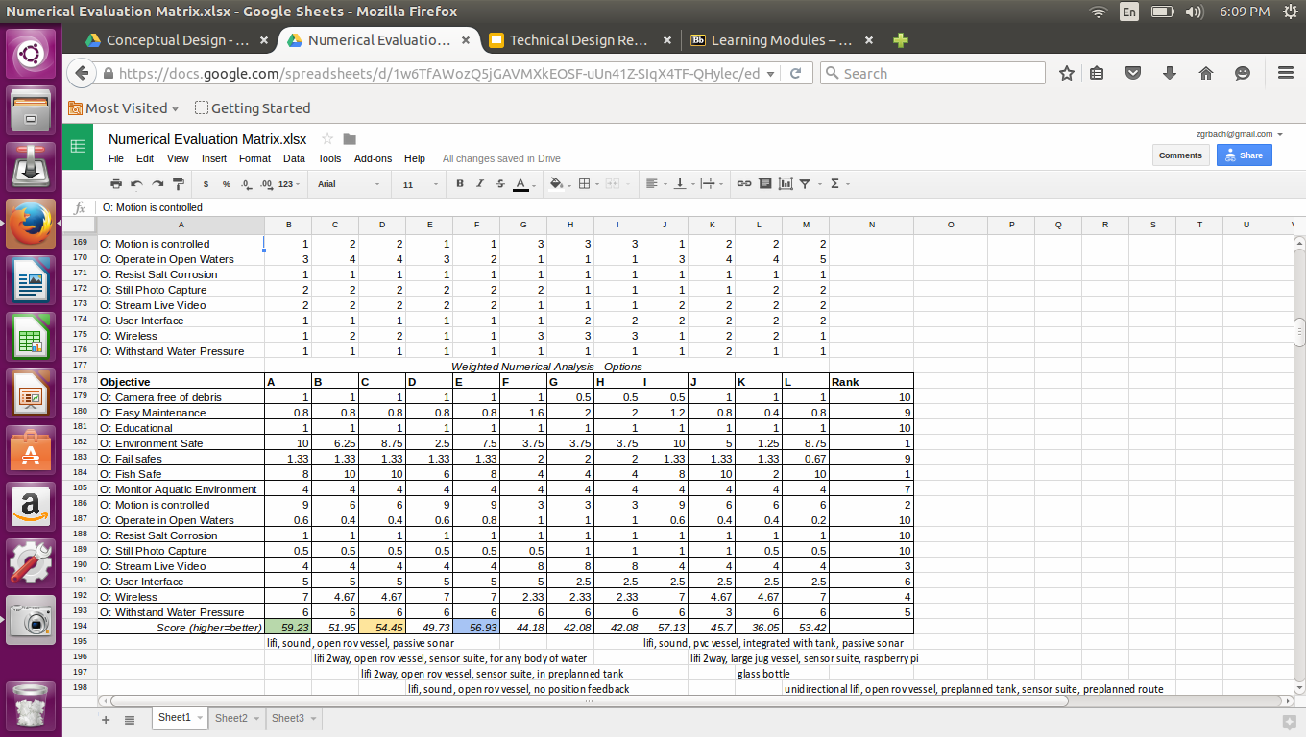

**Table 4.4: Weighted Best-in-Class Chart**

Analyzing these results, we decided to create Design C for two reasons. First, we were given approval to purchase the OpenROV kit. Second, there would not be sufficient time to design both the sonar and optical communication systems. We decided to focus on optical communication and just repeat our design for both the land and submarine. Because our project goals changed significantly, we revised our requirements table, shown in Table 4.5. This version focuses on the testing the optical communication system using the OpenROV for all the submarine requirements, such as motion control and high quality video.

|  |  |
| --- | --- |
| Function | Performance Specification |
| Control of Device | Design must analyze input from users, feedback from current location, and appropriate controls through optics |
| Live Streaming Video | Design must be capable of transmitting video data from submarine to land station in real time through optics |
| Modular Optical Communication | Design must be compatible with Ethernet capable devices and simple to install |

**Table 4.5: Final Version of Requirements Table**

1. **Use of Standards**

**Why Use 10Base-T Ethernet for Underwater Optic Communication?**

One functional requirement for UC the Fish was modular optic communication, or the communication system should be easy to integrate with devices that need to communicate, a plug-and-play solution.

Nearly every modern computer has at least 10Base—T Ethernet and USB 2.0 connectivity, so any “modular” communication attachment should use one of these protocols—at least at its endpoints. We chose to 10Base—T Ethernet, not just at the interfaces but to send the Ethernet signal itself through water in the form of intensity of blue light. This allowed us to focus on building blue light transmit and receive hardware instead of attempting to develop light transmit/receive hardware and a modulation protocol + logic giving it USB endpoints.

Ethernet allows multiple stations to share a single medium, which is appropriate for water because light spreads in every direction and data cannot be multiplexed over different wavelength channels. It includes hardware support for cyclic redundancy bit checking, up to 16 retransmission attempts in the case of bit errors or disruption of the medium, and at 10 MHz, Ethernet is fast enough for live streaming video.

Unlike USB, a temporary disruption in the data link does not require renegotiation time and application level link management. Software applications can use the operating system to handle TCP protocol when data integrity and delivery acknowledgement are necessary, instead of writing custom code to ensure control commands reach the sub intact.

**Getting the Standard**

IEEE Std 802.3 is the standard for Ethernet communication. It is freely available online but is so large it is split into multiple sections. The first section (only 555 pages!) is available at

https://standards.ieee.org/getieee802/download/802.3-2012\_section1.pdf.

**Ethernet Introduction**

Ethernet is a time domain communication protocol for connecting any number of machines via a single, shared medium. Each station is given a unique address when it is manufactured and data is sent serially (1 bit at a time) in packets between stations. The format of a packet is shown in Figure 5.1.

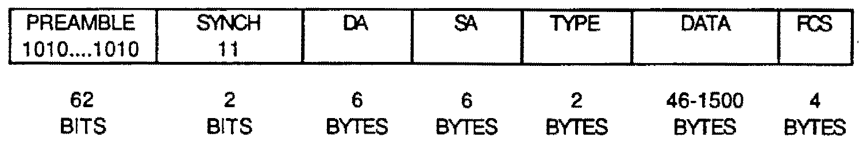

**Figure 5.1: Format of an Ethernet Packet**

Time sharing of the medium is done by all stations following Carrier Sense Multiple Access with Collision Detection (CSMA/CD) protocol. Only one station may transmit at a time but all stations continuously monitor the line, looking for packets addressed to them and seeing when it is available to send packets of their own (CSMA). After completion of a packet, all stations wait an interpacket gap before attempting to transmit. If two stations transmit at the same time, both detect a collision (CD) and backoff for a random period of time. A pseudo random exponential backoff algorithm is used to make repeat collisions unlikely and retransmission is attempted up to 16 times below the level of the operating system.

Ethernet has been in widespread use since the 80s and the standard has evolved over that time. The biggest change was probably the switch from 10 MHz on coax cable to 10 MHz on twisted pair telephone cable, which was then named 10Base--T. The standard is backwards compatible, so even though UC the Fish is only interested in using 10Base--T, it is helpful to describe both to understand all the acronyms, block diagrams, and separation of functions in the standard.

The left panel of Figure 5.2 shows the network topology for the original 10Base-5 coaxial Ethernet. It is easy to see how all stations share the coax medium. Within a single station, there are usually three integrated components: a Media Access Controller (MAC), Physical Layer Signaling (PLS), and Medium Attachment Unit (MAU). The connections between the 3 components are also standardized; between the MAC and PLS is a Media Independent Interface (MII) and between the PLS and MAU is the Attachment Unit Interface (AUI). The standard assigns different functions to each of the three components, and these are shown as sub blocks in Figure 5.2.

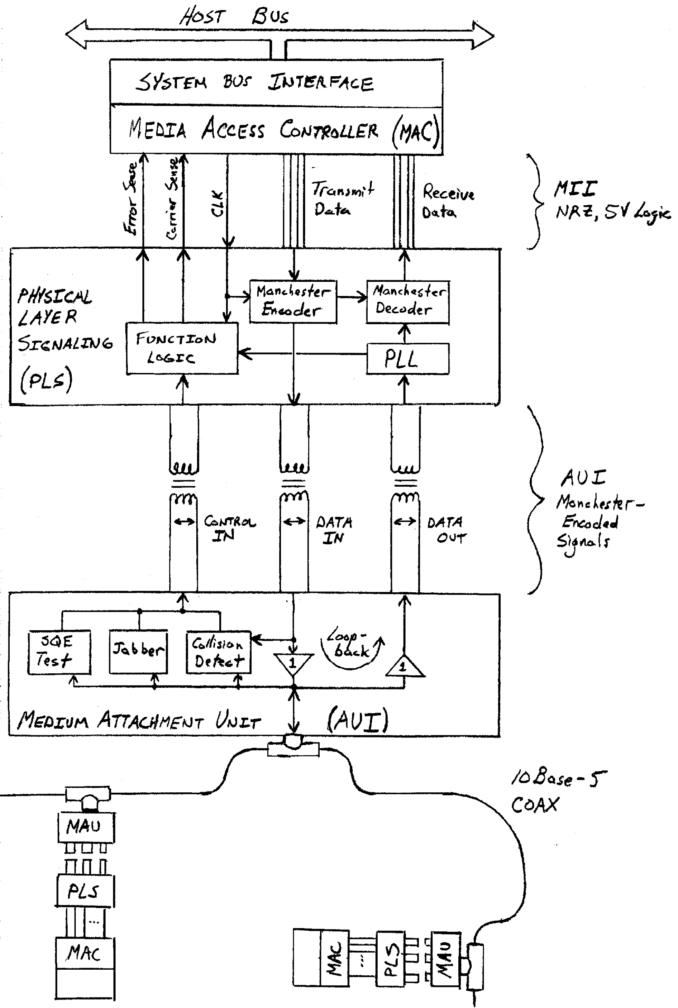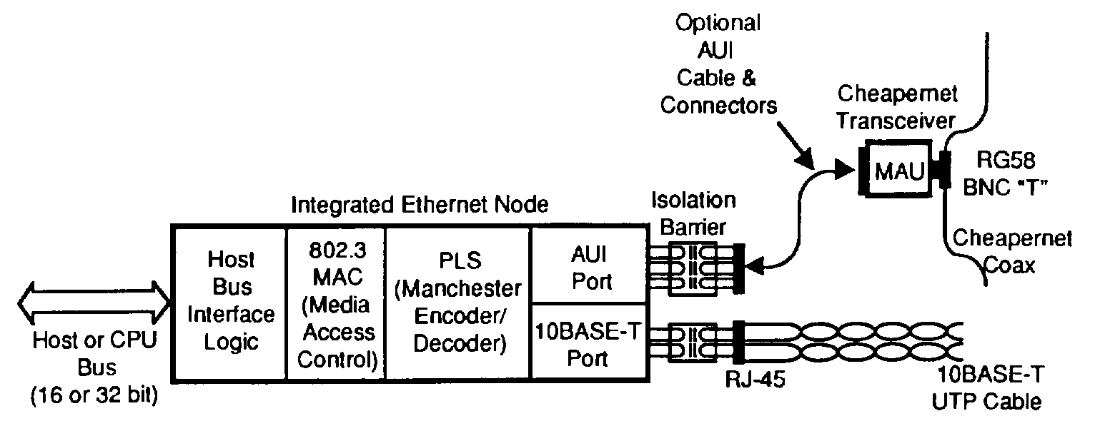

**Figure 5.2: 10Base-5 Coaxial Ethernet (left) vs. 10Base-T Duplex Ethernet (right)**

The MAC holds the stations 48-bit address and is responsible for generating Ethernet packets, unpacking packets with the proper address, and not generating packets when the carrier sense or error sense inputs are high. Ethernet packets generated by the MAC are sent to the PLS with standard 5V logic over the MII. In the standard this 5V logic is called Non Return to Zero (NRZ) because three letter acronyms are super promiscuous.

The PLS has two functions, locking on to incoming packets and converting between 5V NRZ logic and Manchester encoding. It uses a phase locked loop (PLL) to lock onto 64 bit, 5 MHz preambles coming in on the Data In pair. Once locked, the remainder of the packet is decoded with this local clock. The packet is short enough and oscillator accuracy is specified in the standard such that the entire frame can be decoded before the clocks of two stations drift apart.

Manchester encoding is done because standard 5V, DC logic cannot pass through transformers. Transformers are required in the AUI cable so that the station (an expensive computer) and the coax cable are isolated from one another electrically. This way a voltage surge on the medium will not fry the computer. The format of Manchester encoding compared the NRZ data and clock signal is shown in Figure 5.3. An extra transition occurs at the center of every data bit to create an AC signal. The first half of the Manchester signal is the opposite of the NRZ data value, and the second half of the Manchester signal is equal to the NRZ data value.

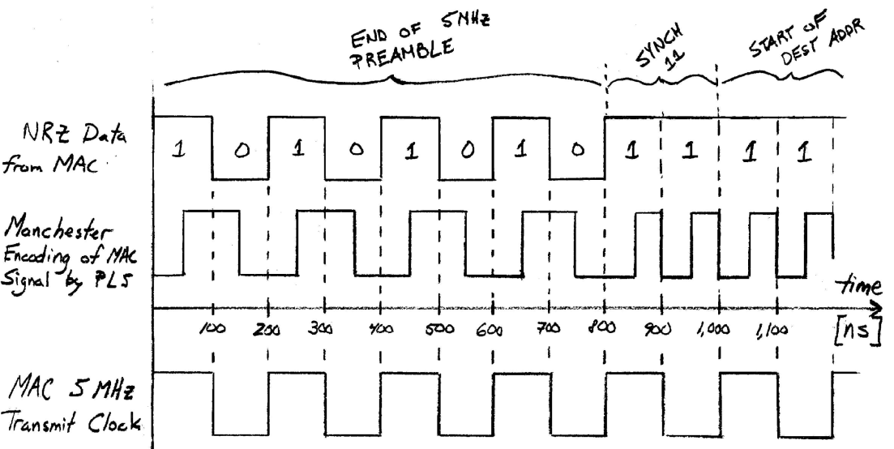

**Figure 5.3: Non Return to Zero and Manchester Encoding**

Finally the MAU (medium attachment unit) forms the actual connection to the Coax. It has amplifiers and also some limited logic for detecting collisions and generating signal quality error (SQE) test pulses on the Control line. The SQE and a loopback function in the MAU allow the PLS to produce an error sense signal if the MAU is not connected properly.

Compared to 10Base-5 coaxial Ethernet, 10Base-T Ethernet requires fewer components and can be manufactured on a single piece of Silicon. The right panel of Figure 5.2 shows how using two twisted pairs simplifies the station by eliminating the need for a separate MAU. The other major different of 10Base-T is the topology. Each twisted pair cable is a 1-to-1 link between a station and a hub. The hubs can be made with varying degrees of intelligence so that packets not addressed to a station are not sent on that station’s receive (Rx) pair. In this way the hubs form a “logical coax” where collisions occur much less frequently and data throughput is increased.

**Influence of Ethernet Standard on Transmitter/Receiver Design**

The use of Ethernet has a large effect of the design of UC the Fish. The overall circuit topology matches the 10Base-T network topology for connecting two computers and there are specific electric requirements from the standard. The specific design constraints from the standard are:

1. The first component in the light transmitter input and last component of the receiver output should be a 1:1, Ethernet approved transformer and standard RJ45 connector.
2. The input impedance of light transmitter must be 100 Ω.
3. The bandwidth of both light transmitter and receiver must exceed 10 MHz by several harmonics.
4. The phase shift between 5 MHz and 10 MHz should be negligible.
5. The magnitude response of light transmitter + receiver in series, to a 100 ns, 585 mV step input, should be ≥ 585 mV when loaded by 100 Ω.

**Limitations of Ethernet for Underwater Communication**

There are two limitations associated with sending 10Base--T Ethernet signals, unmodified, through water by modulating light intensity. Both are related to the separation of transmit and receive pairs in 10Base--T, and how stations detect collisions.

First, is the isolation of transmit and receive signals in twisted--pair media. The 10Base—T Ethernet hardware on modern computers expect to operate in full duplex mode, that is when they still listen on the receive line for when other stations own the network, but when they transmit they expect silence on the receive pair--they do not expect to hear their own signal. If the station hears anything on the receive line when it is transmitting, it interprets it as a jam signal from a router and stops transmitting immediately.

This is a limitation in sending Ethernet as light: there will be some level of reflected light due to the optical interface and from particles in the water. If the receiver circuit is built to have a fixed gain, then it must be below the threshold at which it would jam itself.

To determine at what distance and signal magnitude this might occur, tested the current response of the photodiode to the blue LED with 20 mA current in water at different distances. A 5 inch acrylic security camera dome was used and the test was performed in tap water. The results, shown in Figure 5.4 suggested that the overall gain should be less than

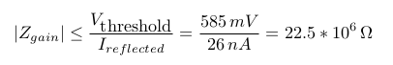,

corresponding to a maximum distance of 25 centimeters within which 10Base—T Ethernet can function with constant gain, analog transmit/receive circuits.

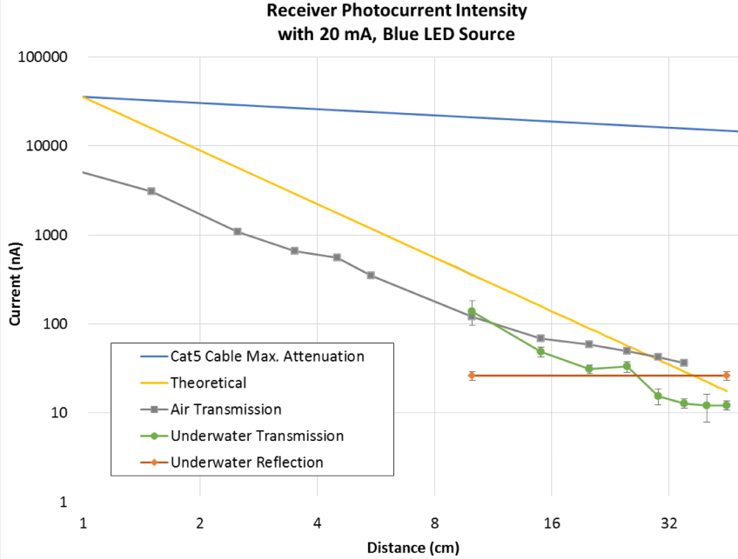

**Figure 5.4: Crossover Point: the distance at which reflected light from station A's own transmitter is more intense than light arriving from far—away station B's. I.e. the distance at which water/light stop behaving like an Ethernet crossover cable**

The second limitation of 10Base—T Ethernet is due to the required link integrity test specified in the standard. A station is not allowed to transmit unless it hears either incoming packets or a special pulse from a router indicating no traffic but good connection. This means that a one—way link cannot be tested; both directions must be complete in order for either station to send out data.

This does not limit the final product, but it does make it more difficult to test prototypes: two transmit and two receive circuits must be built and if any one piece doesn't work, then neither computer will even try to broadcast data. To help with this problem, UC the Fish built a special Ethernet cable with one Tx—Rx pair connected and the other opened with Tx and Rx RJ45 plugs. The cable can be used as shown in Figure 5.5.

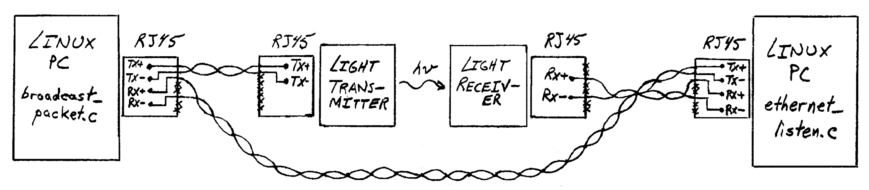

**Figure 5.5: UC the Fish Test Setup, using custom crossover cable, two Linux PCs, and test programs broadcast_packet.c and ethernet_listen.c included in the appendices.**

1. **Design Overview**

**OpenROV Construction**

The focus of our project was designing an optical communication system to replace a tether in a submarine, called the OpenROV. The OpenROV is an open-sourced, underwater drone, with live HD video streaming and motion control capabilities. The OpenROV comes with a user interface. After receiving the kit, we constructed the OpenROV as instructed in the given How-to Guides. A few steps of the construction process are pictured in Figure 6.1. The final OpenROV submarine is shown in Figure 6.2.

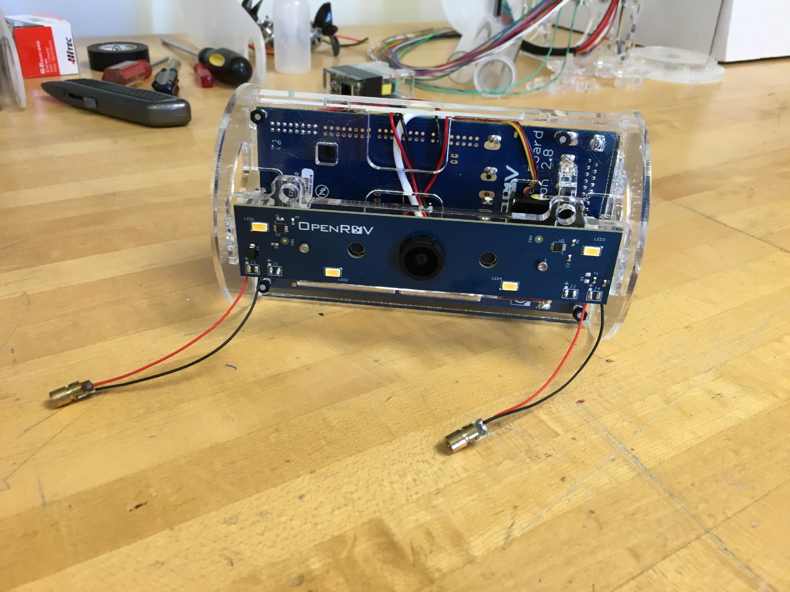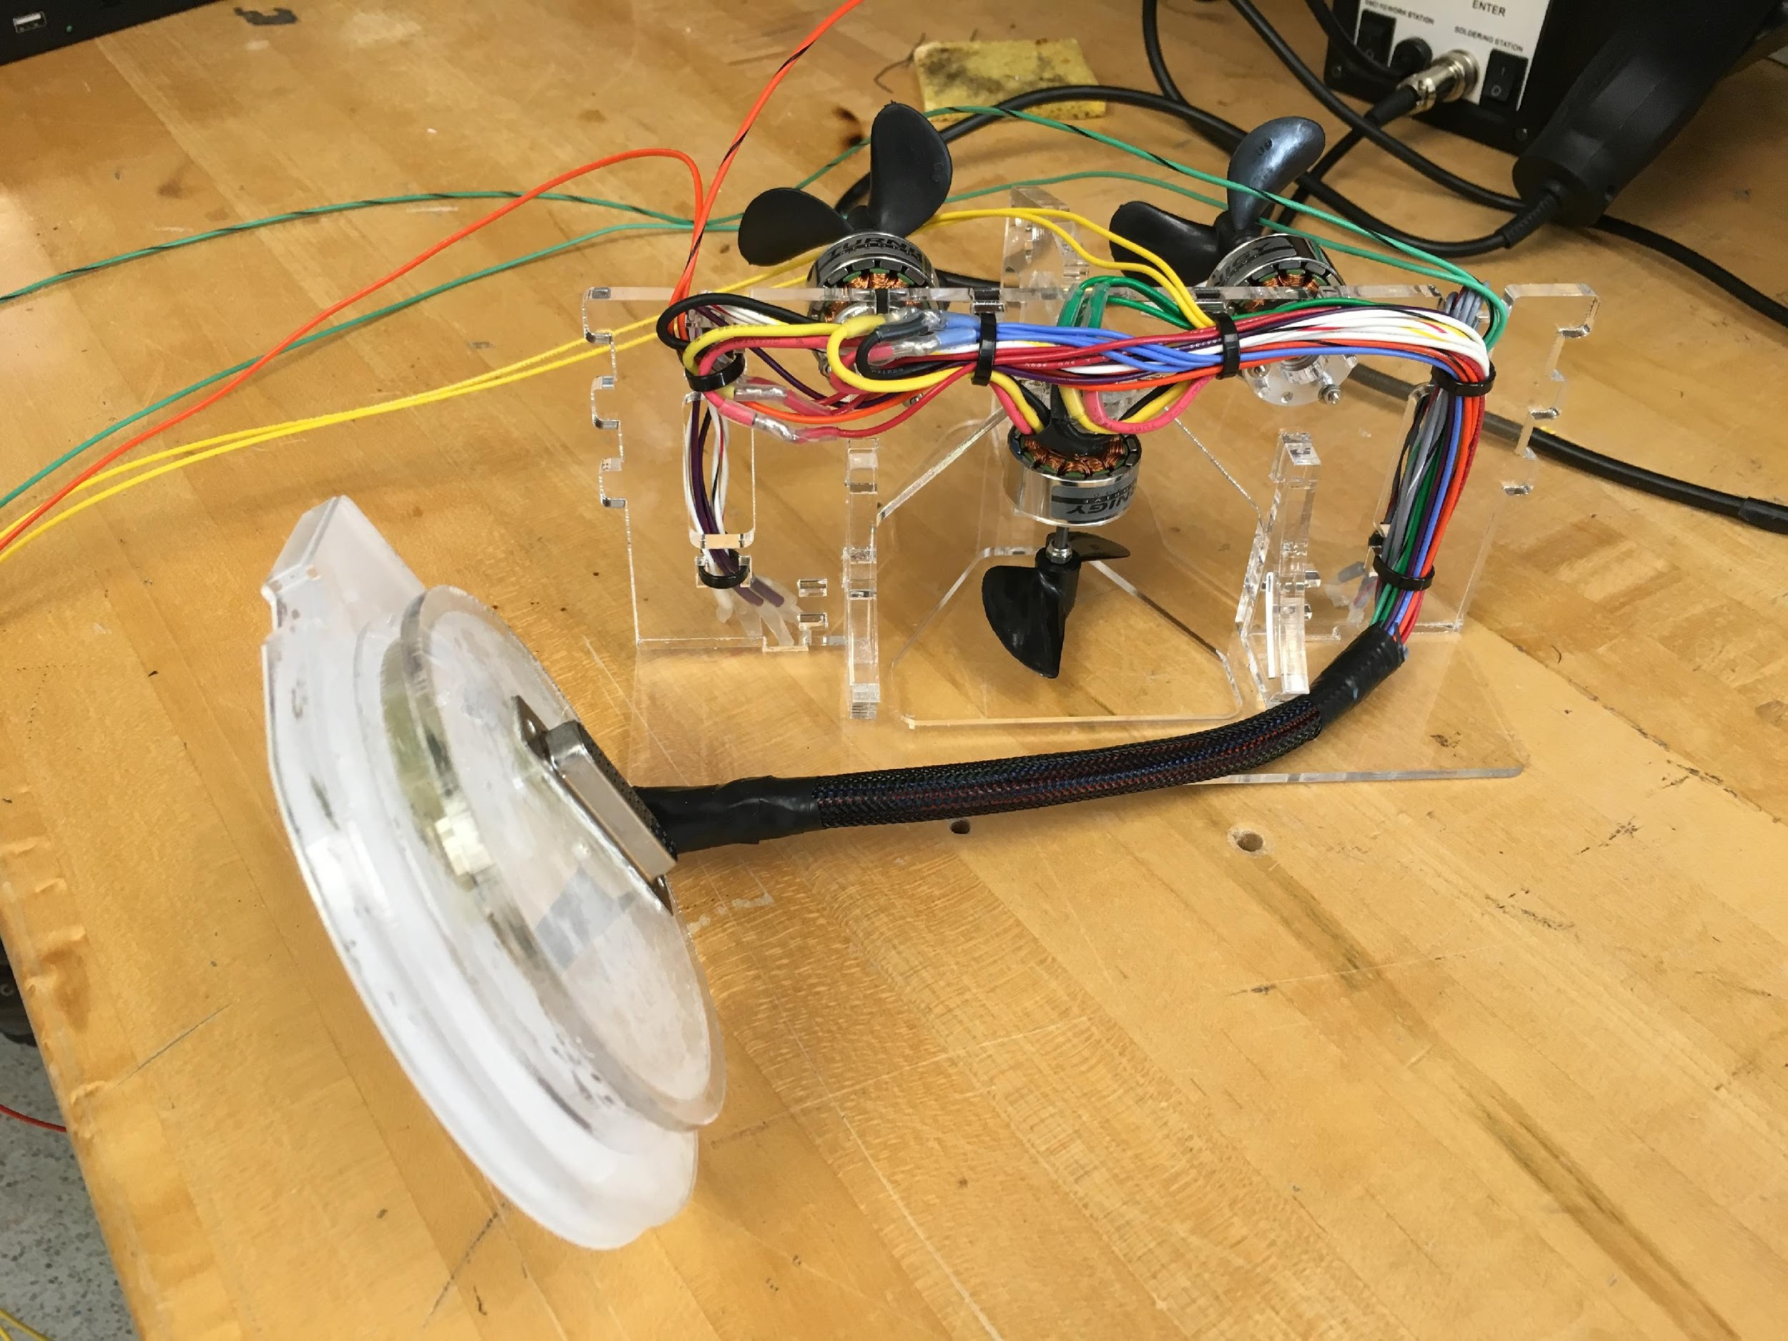

**Figure 6.1: Electronics Assembly and Wire Routing for OpenROV**

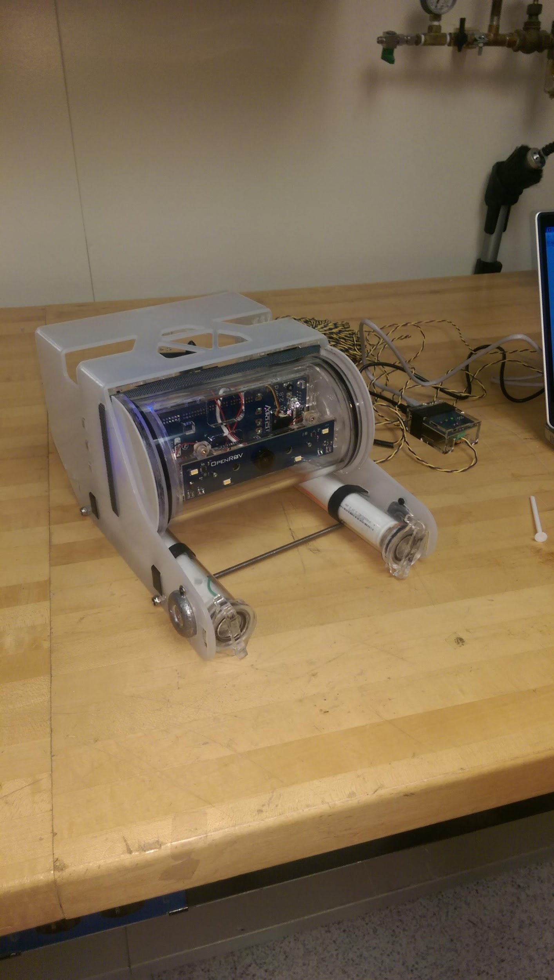

**Figure 6.2: Final Assembly of OpenROV**

We analyzed the layout of the OpenROV to locate where the optical communication system board could be inserted in place of the tether. The OpenROV contains three circuit boards: BeagleBone Black, Arduino Mega, and Tenda Adapter. The BeagleBone Black is the “brains” of the system. This board interprets signals from the computer and informs the Arduino Mega on how to operate the motors to control the submarine’s motion. In addition, it converts the video signal from the camera to Ethernet signal to be sent back to the computer using Ethernet protocol. The Tenda Adapter converts the full duplex Ethernet signal from the BeagleBone Black to a signal that can be sent through the two-wire tether. On land, the tether connects to another Tenda Adapter. This Tenda Adapter converts the signal back to full duplex Ethernet and sends it to the Topside Interface board. This board interfaces with the computer.

For our design, we will intercept the Ethernet signal between the BeagleBone Black and Tenda Adapter on the OpenROV. This signal will be routed to the optics board to be transmitted. In addition, the received signal will come from the optics board instead of the Tenda Adapter board. On the land side, the Topside Interface board and Tenda Adapter will be completely bypassed. The optics board will be plugged in directly to the computer, using an Ethernet cable. Figure 6.3 shows the connections described. The dashed lines are the original OpenROV connections that will be removed when using the optics board.

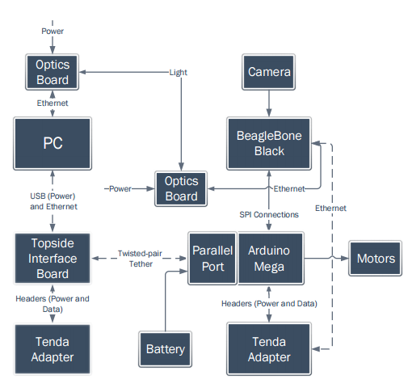

**Figure 6.3: OpenROV Connections Diagram**

**Preliminary Design**

After construction of the submarine, we designed the optical communication system, through considering one transmitter and one receiver.  The transmitter was designed to take the Ethernet signal from the computer and convert it to light. The receiver was designed to detect the light from the transmitter and convert it back into an electrical signal. This system is shown in Figure 6.4.

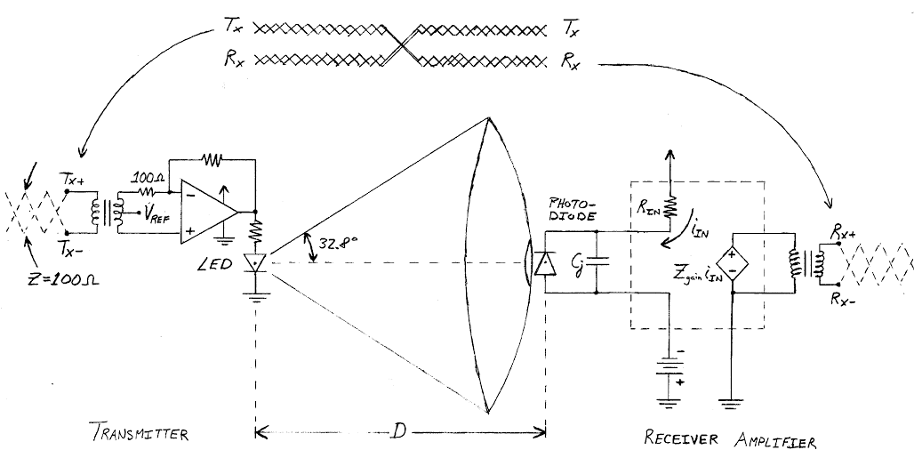

**Figure 6.4: Basic Optical Communication System**

Through analyzing this system, we calculated the required gain for the receiver circuit to meet the 585mV Ethernet specification. First, we calculated the radiant intensity of the LED using the equation:

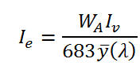.

The values used in the equation are given in the LED’s datasheet. Next, this value was used to calculate the current in the photodiode, using the equation:

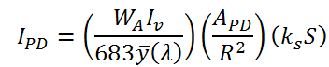.

The R value is the distance between the photodiode and the LED. The other variables are given in the photodiode’s datasheet. Finally, the required gain is calculated using the equation: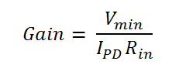.

Vmin is based on the Ethernet protocol specification that requires a HIGH signal to have a voltage above 585mV. The resistance value is based on the low pole formed with the photodiode capacitance. The equation for this value is shown below:

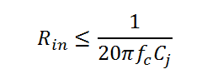.

The corner frequency must be larger than the 10MHz Ethernet requirement. After, calculating the required gain based on the distance, we designed the optical transmitter and receiver circuits. The derivations used to calculate the values in the circuit are located in the appendix of this report.

**Optical Transmitter**

The Ethernet signal is inputted to an optical transmitter board. This board connects the TX lines to the inputs of an operational amplifier with a gain of 10 V/V. The output of the op amp is connected to a blue LED. A blue LED was used because it has the least attenuation in saltwater, and has a fast enough frequency to transmit live video. When the TX signal is high, the LED has 20mA across it. This causes the LED to flash on and off at the 10MHz Ethernet requirement. The schematic for the final optical transmitter design is shown in Figure 6.5.

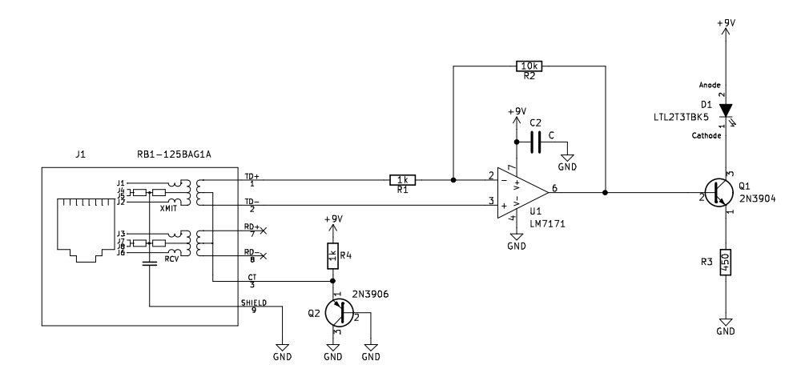

**Figure 6.5: Optical Transmitter Schematic**

**Optical Receiver**

The optical receiver consists of a photodiode that detects the transmitter’s LED signal and four amplifier stages. The chosen photodiode is able to detect blue light with a responsivity of 0.18 A/W. The first amplifier stage is a common-base bipolar junction transistor (BJT) design with a current mirror to control current flow. The current from the photodiode is amplified and converted to a voltage signal with a gain of approximately 100 V/A. Figure 6.6 shows the schematic for the first BJT amplifier stage.

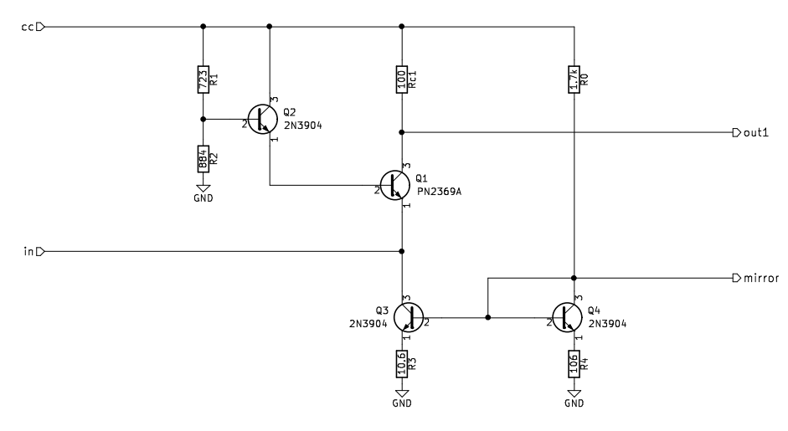

**Figure 6.6: Schematic of the First BJT Amplifier Stage in the Optical Receiver**

The second amplifier stage is a common-emitter BJT amplifier with a gain of approximately 10 V/V. The common-emitter output is fed through a common-base configuration to increase the frequency response of the circuit. Figure 6.7 shows the schematic for the second BJT amplifier stage. These stages are coupled with an inductor and capacitor in order to reduce noise and oscillations throughout the circuit.

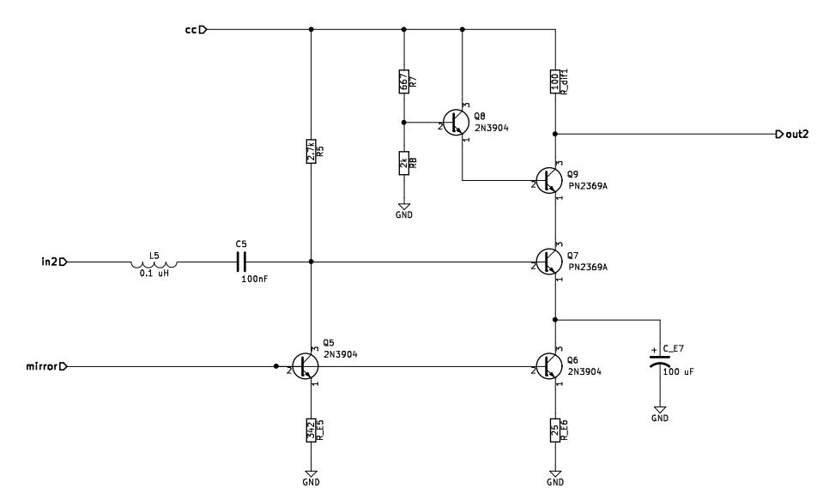

**Figure 6.7: Schematic of the Second BJT Amplifier Stage in the Optical Receiver**

After the BJT stages, the signal is passed through two operational amplifier stages with a gain of approximately 10 V/V each. Initially, these stages caused high frequency oscillations with a magnitude of approximately 200mV. These stages were redesigned, and a feedback capacitor of 2pF was added. The final optical receiver design that eliminated the oscillations is shown in Figure 6.4.

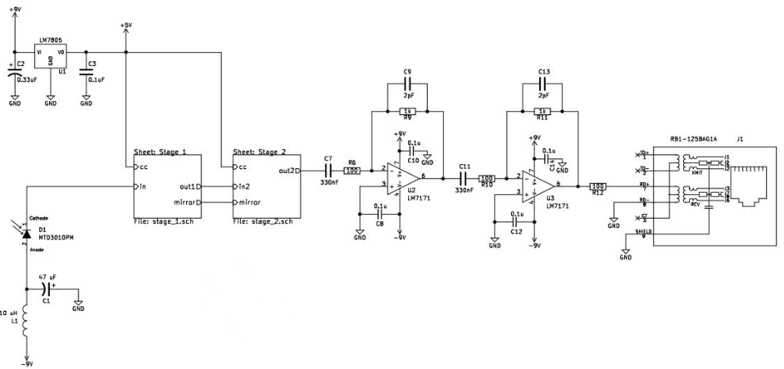

**Figure 6.4: Schematic of the Complete Optical Receiver**

The complete bill of materials for the OpenROV kit and the optical communication boards is listed in Table 6.1 below.

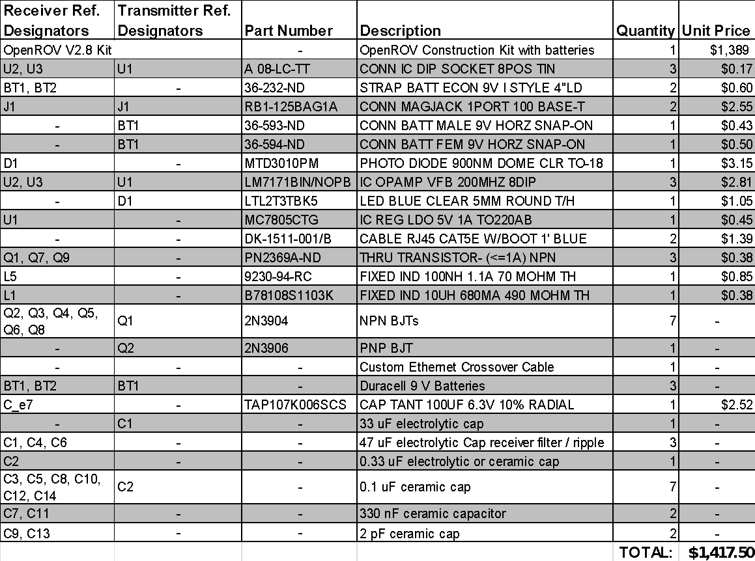**Table 6.1: Bill of Materials**

1. **Test Plan, Cascade Matrix and Project Limitation**

The test protocol for an optical communication system in place of the tether in the OpenROV is shown in the text blocks below. This document details a procedure for validating our final proposed project and is geared toward the end-user. Test Protocol 1.1 validates modular optic communication. Test Protocol 1.2 validates control of device and live streaming video through the optical communication system.

|  |
| --- |
| Test Protocol 1.1 – Modular Optic Communication   1. **Set-up on Submarine**    1. Remove the OpenROV batteries.    2. Disconnect the tether from the waterproof tether connector.       1. Cap the waterproof connector with a plug.    3. Remove the caps from the optics dome waterproof connector as well as the Ethernet connector.    4. Use the short cable to connect the optics dome connector and Ethernet connector together. 2. **Set-up on Land**    1. Plug the land station dome into the laptop for the USB and Ethernet connections.    2. Replace the batteries back into the OpenROV tubes.    3. Test the connection with the Ethernet broadcast problem 3. **Rating**    1. Using a Likert scale of 1 (Impossible to change) to 5 (Extremely easy to change connections), what is simplicity of switching the communications? **____** |

|  |
| --- |
| Test Protocol 1.2 – Control of Device & Live Streaming Video   1. **Set-up Submarine**    1. Set-up the OpenROV as described in the operator's manual located at this link: <http://openrov.dozuki.com/Guide/OpenROV+Operators+Manual/80> 2. **Set-up Underwater Obstacle Test**    1. In the deep end of a pool or a still, clear freshwater environment at least 10 ft deep, place four heavier-than-water objects 10 ft apart in a rough square pattern.    2. The shallow end of the pool or body of water should be at least 50 meters away in a straight path for a range test. The straight path should have a direct line of sight for optics. 3. **Testing Procedure**    1. Go through tests outlined below using the included tether that came with the OpenROV kit for a baseline comparison.    2. Disconnect the tether and connect the optics board to the OpenROV as described in TP 1.1.    3. Go through tests outlined below using the optical communication boards. 4. **Preliminary Testing**    1. Place OpenROV in water.    2. Live Streaming Video       1. On a Likert scale to 1 (No Video) to 5 (High Quality), what is the quality of the video?   Tethered: **____**  Optical: **____**   * + 1. On a Likert scale of 1 (Still Picture) to 5 (Real-time), rate the lag of the video.   Tethered: **____**  Optical: **____**   * 1. Control of Device      1. Using the *up* *arrow* key, move the OpenROV forward.      2. Using the *down* *arrow* key, move the OpenROV backwards.      3. Using the *left arrow* key, move the OpenROV left.      4. Using the *right arrow* key, move the OpenROV right.      5. Using the *shift* key, move the OpenROV up towards the surface.      6. Using the *ctrl* key, move the OpenROV deeper into the water.      7. Using the *o* and *p* keys, turn up and down the brightness of the camera lights.      8. Using *a*, *q*, and *z* keys, move the camera on the servo.      9. Did the OpenROV operate as instructed using the keys?   Tethered: **____**  Optical: **____**   1. **Obstacle Course Testing**    1. Use the *arrow*, *shift*,and *ctrl* keys to navigate the underwater obstacle course set up in Section 2. The user should not be in direct line of sight of the submarine. The video display on the user interface should be used to determine submarine location.    2. Touch the submarine to the closest object on aquatic environment floor.    3. Begin the timer.    4. Move in a clockwise fashion and touch the second object.    5. Move in a clockwise fashion and touch the third object.    6. Move in a clockwise fashion and touch the fourth object.    7. End the timer.   Tethered time: **____**  Optical time: **____**  **NOTE:** The time of running through this course should be used to quantify validation of the control of device and live streaming capabilities.   * 1. Using a Likert scale of 1 (Impossible to navigate) to 5 (Extremely easy to navigate), what is easiness of navigating the obstacle course?   Tethered: **____**  Optical: **____** |

As seen above, there are no results recorded for this test protocol. Unfortunately, this test protocol does not allow us to show the operational aspects of our final product. The final prototype failed all validation of its required functionality, as shown in the cascade matrix in Table 7.1. The failure is a direct result of many unforeseeable project limitations that occurred throughout this semester. As a result, we designed potential solutions that could be implemented with more time.

|  |  |  |  |  |  |
| --- | --- | --- | --- | --- | --- |
| **Function** | **Performance Specification** | **Design Verified?** | **Test Protocol** | **Device Validated?** | **Signature** |
| Modular Optic Communication | Design must be compatible with Ethernet capable devices and simple to install | Yes* 2/26/2016 | TP 1.1 | No | 4/4/2016 |
| Control of Device | Design must analyze input from users, feedback from current location, and appropriate controls through optics | Yes**  3/03/2016 | TP 1.2 | No | 4/4/2016 |
| Live Streaming Video | Design must be capable of transmitting video data from submarine to land station in real time through optics | Yes** 3/03/2016 | TP 1.2 | No | 4/4/2016 |

**Table 7.1: Cascade Matrix**

*\*Verified by finding where on the OpenROV the Ethernet board would be connected.*

*\*\*Verified through simulations with comparator, light reflection test, and other initial tests.*

The project required amplification of a signal that is detected by the photodiode in the optical receiver, which is extremely small and in the range of nAmps. When there is no distance between the transmitter and receiver, this signal needs to be amplified to greater than 100,000 V/A to reach the 585mV Ethernet specification. When separating the boards, the required gain increases by a factor of the distance squared. In addition, the signal must maintain its integrity in order to meet the high frequency specification of 10Mbps Ethernet protocol.

As a result, our final built design addressed some of these requirements, but was unable to be completely integrated together. The constructed optical receiver is able to detect the 10MHz signal at 1 mm and amplify it to approximately 100,000 V/A. One issue that occurred during testing was high frequency oscillations. These oscillations were inconsistent and difficult to analyze. Eventually, we discovered that they were caused by an input capacitance in the op amp that depended on the surrounding environment. We changed the adjacent resistor values and added a 2pF feedback capacitor. This eliminated the oscillations. However, we did not have time to test and construct the final stage of our design, a comparator amplifier. Through simulations, we proved that adding a comparator as the final stage will create enough gain to meet the Ethernet protocol at a significant distance. However, when attempting to construct the simulated circuit, the comparator caused additional oscillations to occur. With slight design modifications and testing, a comparator stage would complete our optical receiver design and meet the Ethernet protocol requirements.

The constructed optical transmitter meets its requirements. It takes in an Ethernet signal and turns a LED on and off at 10MHz. However, because the optical receiver was not completely operational, our test protocol could not show the operation of the transmitter. In addition, the circuit is designed so that additional LEDs can be added in parallel. This design can be used to solve another major project limitation; the constructed optical transmitter has a small light emittance. Adding additional LEDs to the transmitter would increase the signal detected by the photodiode, and allow the submarine to move in a larger range.

On the optical receiver, more photodiodes can be added in parallel with slight design modifications to the circuit. A limitation of the chosen photodiode is that its half viewing angle is 52°, as shown in Figure 7.1. This data was collected in the lab using a simple 100kHz transmitter-receiver pair. To address this problem, the photodiodes could be placed in a geometric shape called the truncated icosahedron, which is similar to a soccer ball. This configuration is shown in Figure 7.2. This placing of photodiodes is designed to detect an even distribution of incoming light.

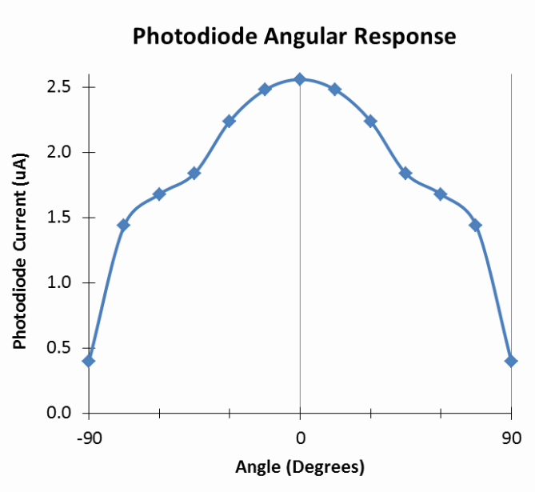

**Figure 7.2: Angle Effect of Light Source on Photodiode**

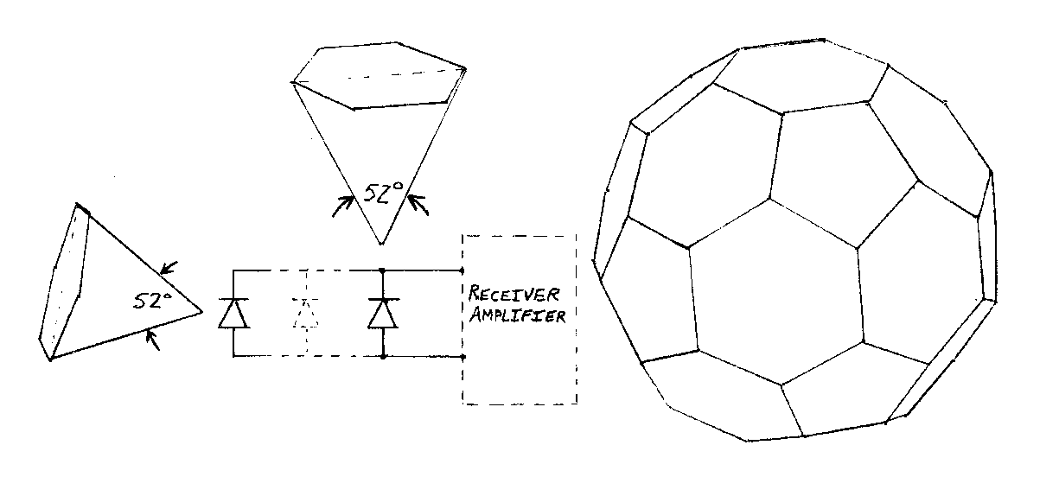

**Figure 7.1: Truncated Icosahedron Form for the Photodiodes**

1. **Social Responsibility**

The social implications of an underwater submarine communicating wirelessly through optics are extremely important. The ability to have high-speed communication through saltwater is something that simply does not exist right now. Since the earth’s surface is 70% water, we are currently horribly handicapped in transmitting data in a medium that dominates our planet’s surface. Our oceans need technology capable of operating safely and effectively in them.

In addition, our project meets our societal responsibility to protect and maintain the environment. The oceans would greatly benefit from an optical communication system, which can transmit large amounts of data quickly. It would allow us to monitor the health of this valuable ecosystem and give us information on how to care for it. Currently, the wireless communication systems used in the ocean rely on sonar to transmit data. However, this lacks in two areas. First, it is not able to achieve as high of data rates. Second, sonar technology may cause disturbances in aquatic life by upsetting frequencies commonly used to communicate between organisms. A graph showing the sensitivity of different sonar frequencies is in Figure 8.1. This is discussed further in our design plan and should be considered a major advantage of not using sonar in our design.

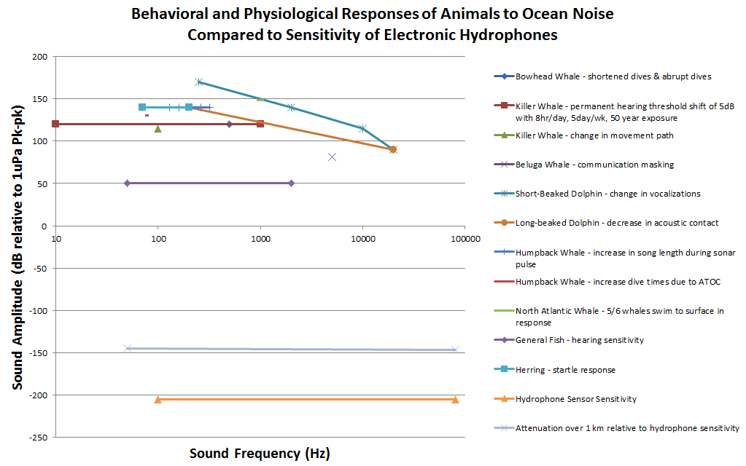

**Figure 8.1: Aquatic Life and Their Sensitivity to Noise Frequencies**

1. **Conclusion**

In summary, we focused on the general submarine during the first semester of Senior Design. This work ensured that our final design have complete functionality required to operate as a video-streaming, remote-controlled aquarium submarine. Near the end of the first semester, the OpenROV was presented as a commercially available system that met a majority of our project attributes and requirements. As a result, the focus of our Senior Design project shifted to creating a wireless communication system for the OpenROV. Specifically, our project’s objective was to design a modular, Ethernet-compatible optical communication system.

During the second semester, we committed our time to creating two optical boards that pass data to and from the OpenROV. These analog circuits are designed to easily replace the current tethered communication link. The optical transmitter board inputs an Ethernet signal and converts it to an optical signal using an LED. The optical receiver board uses a photodiode and a series of amplifiers to create an electrical Ethernet signal from the optical signal.

The final iteration of our optical transmitter board is shown in Figure 9.1. The previous designs were built on breadboards and perfboards. The final prototype was milled from a CNC router machine. This was extremely helpful in reducing noise resulting from the high-speed circuitry. Even though the transmitter was less technically difficult to build, it is important that the switching noise from operating the LED be kept at a minimum.

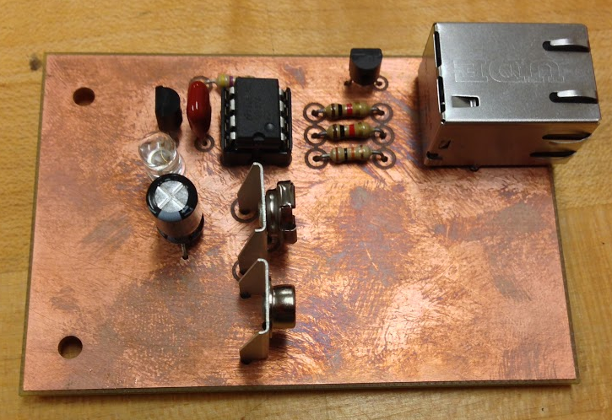

**Figure 9.1: Optical Transmitter Board**

The final prototype of the optical receiver board is shown in Figure 9.2. This board was also milled using a CNC router machine. Since extremely high gains were required, the board needed to introduce as little noise as possible to the signal. A frequency sweep was taken of the final prototype of the receiver board. This response was measured using a test signal inputted to the transmitter board from a waveform generator. A fiber optic cable was used to mimic a water channel. The resulting bode plot of the gain is shown in Figure 9.3.

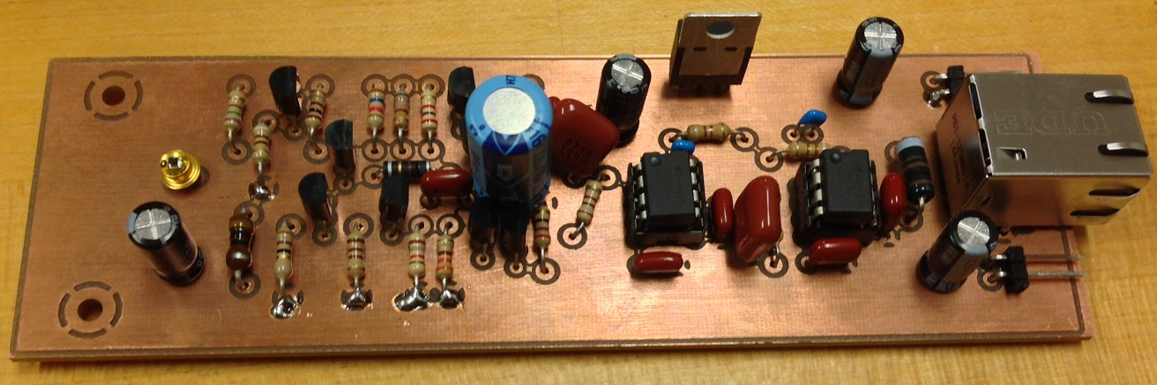**Figure 9.2: Optical Receiver Board**

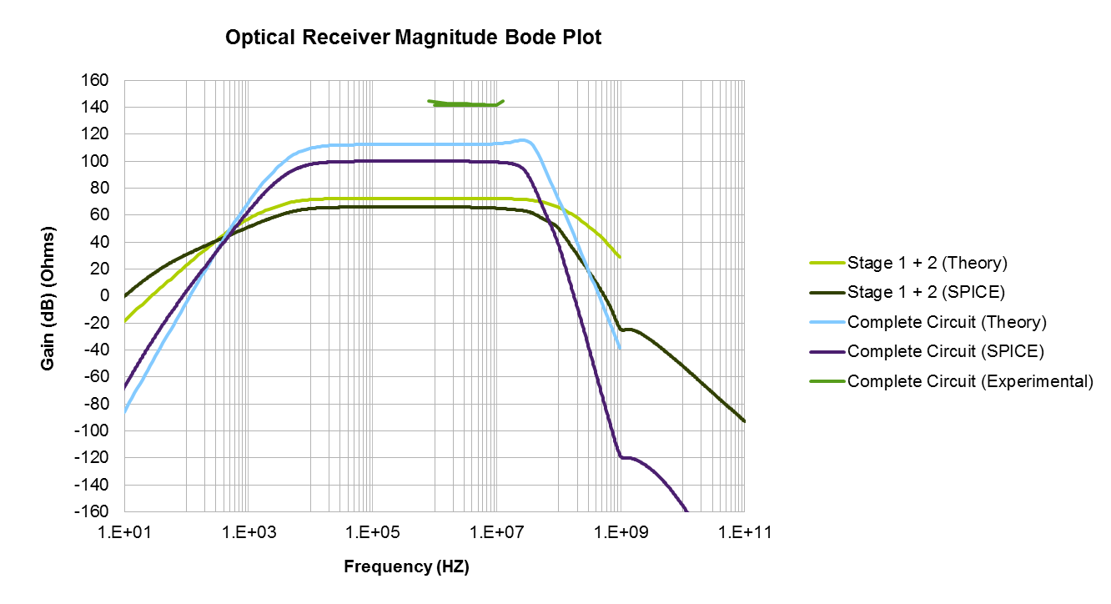

**Figure 9.3: Bode Plot of Magnitude of Optical Receiver Output**

The cascade matrix shows that our project’s requirements were not validated by the final prototype. This was a result of the individual optical boards not being sufficient to meet the specifications of Ethernet. Replacing the tether on the OpenROV with our current prototype would result in an inoperable sub. However, with additional time, a comparator stage could be added to the optical receiver. In theory, this stage produces enough gain to meet Ethernet protocol at a significant distance. Overall, this project showed that optical communication using an LED and photodiode is a viable high-speed, wireless communication system for an aquarium submarine.

1. **Appendix**

**DHF Signature Sheets**





**Optical Receiver: Stage 1 Common-Base Amplifier Derivations**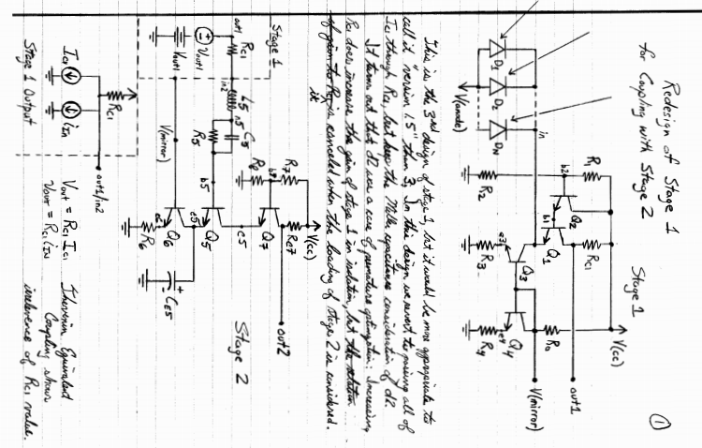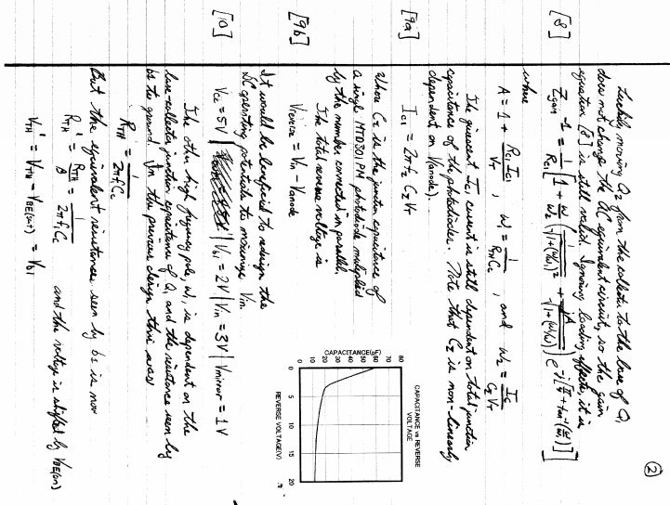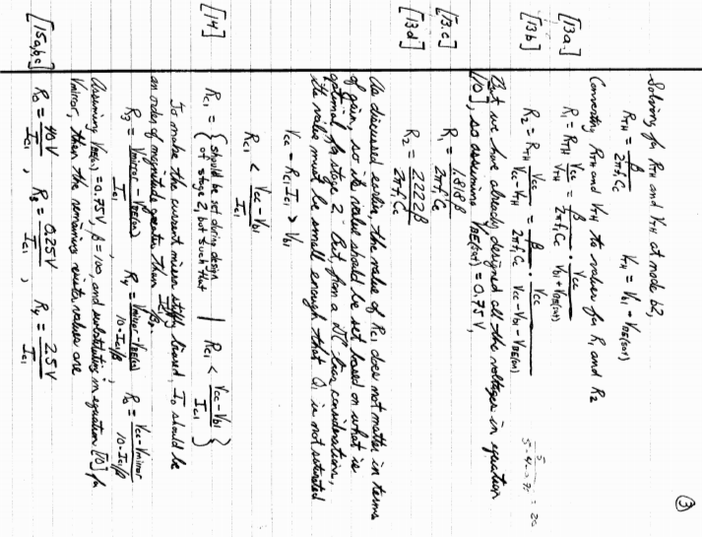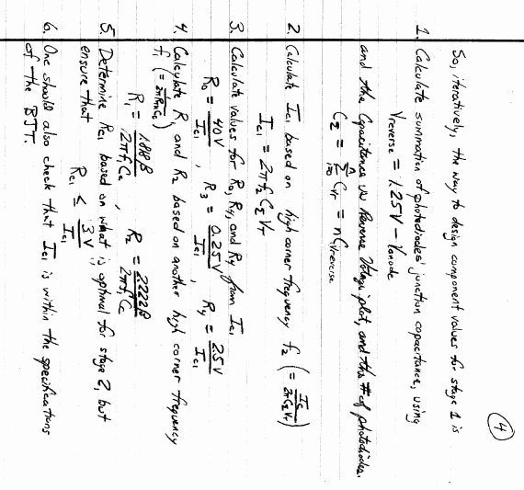

**Optical Receiver: Stage 2 Common-Emitter Amplifier Derivations**

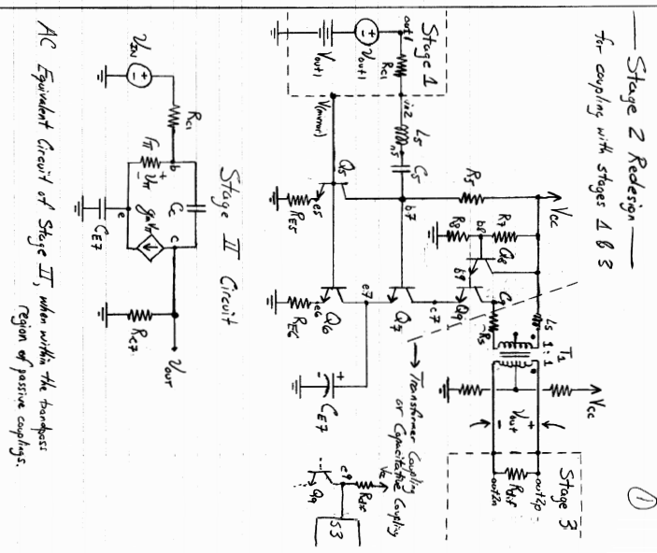

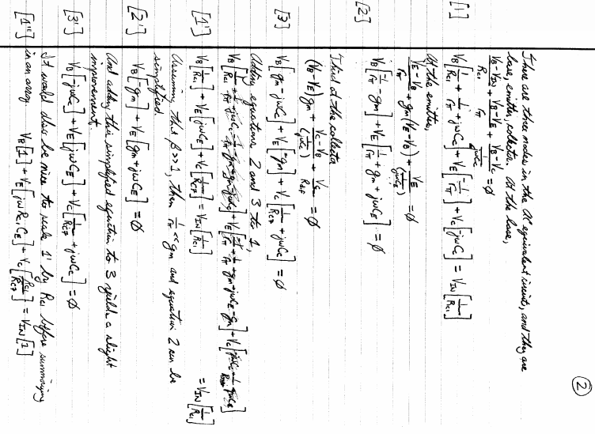

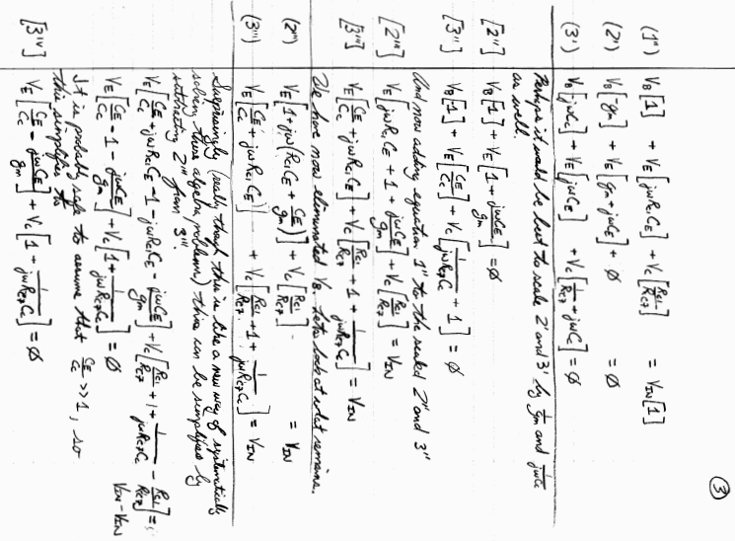

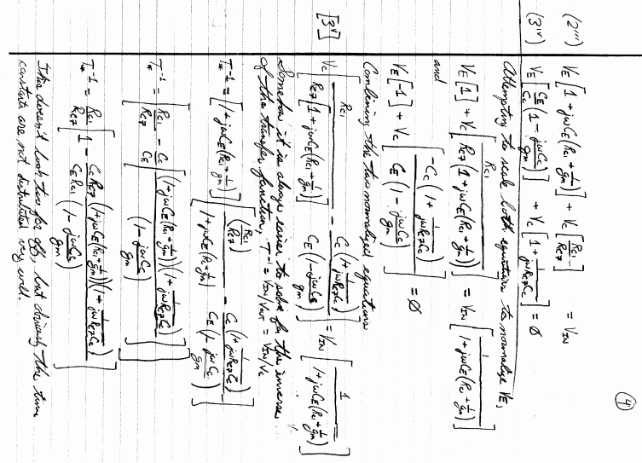

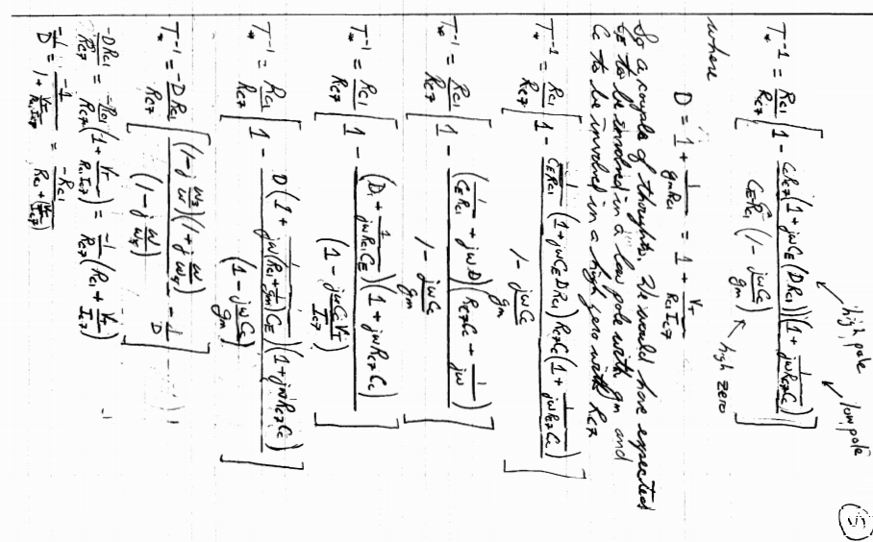 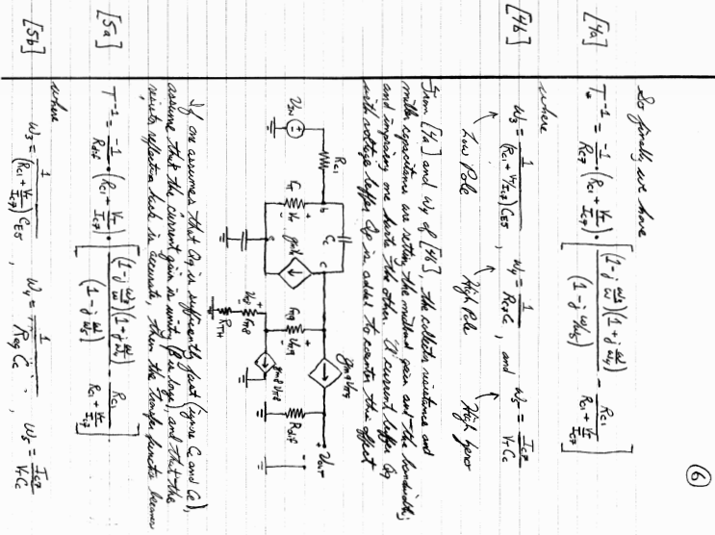 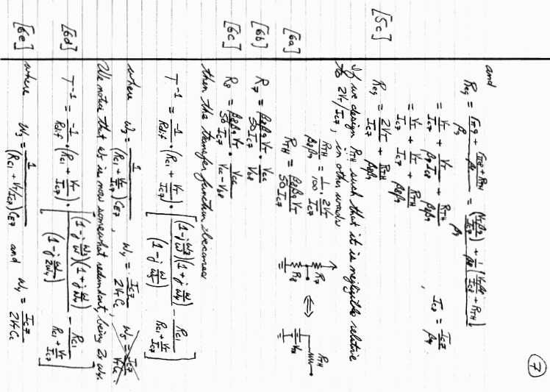 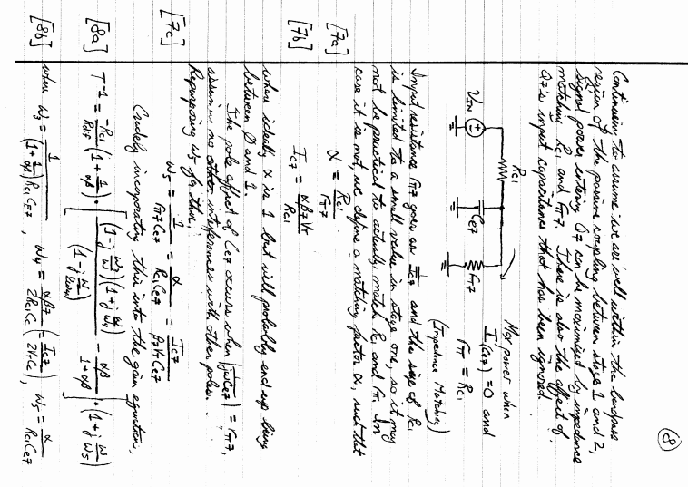 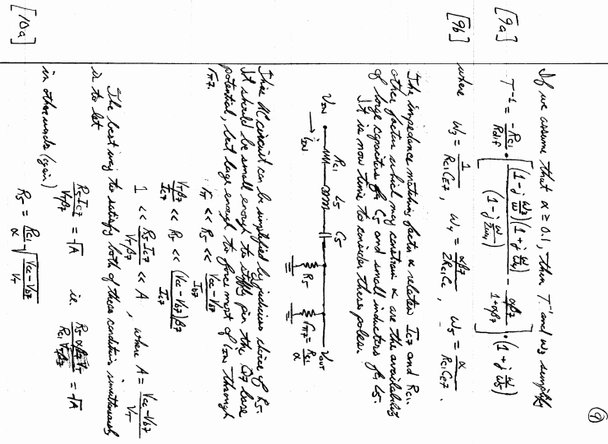

 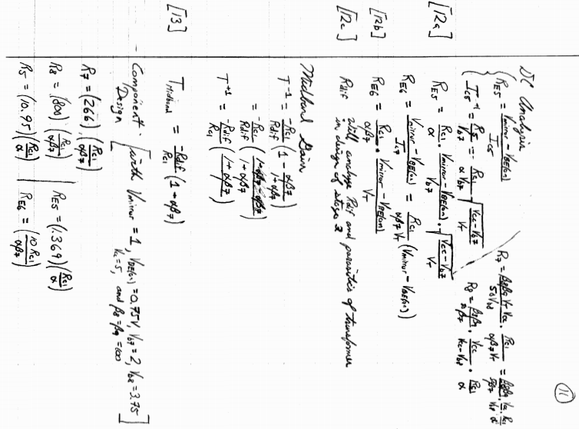 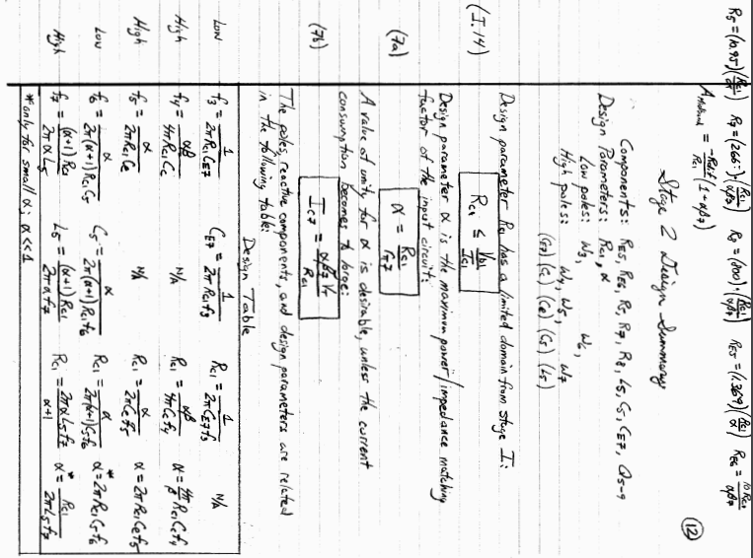

**Optical Receiver: Stage 3 and 4 Operational Amplifier Derivations**

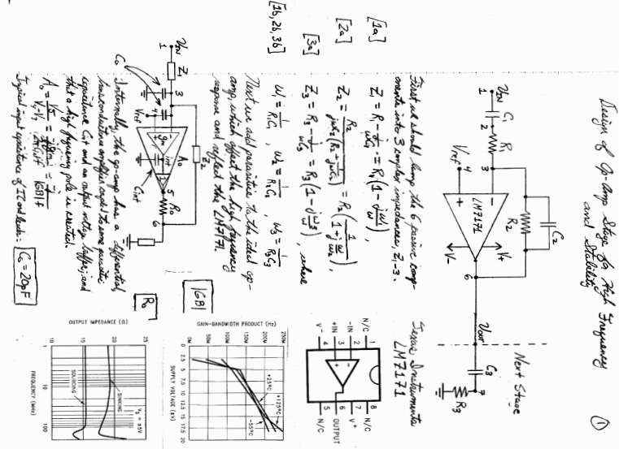

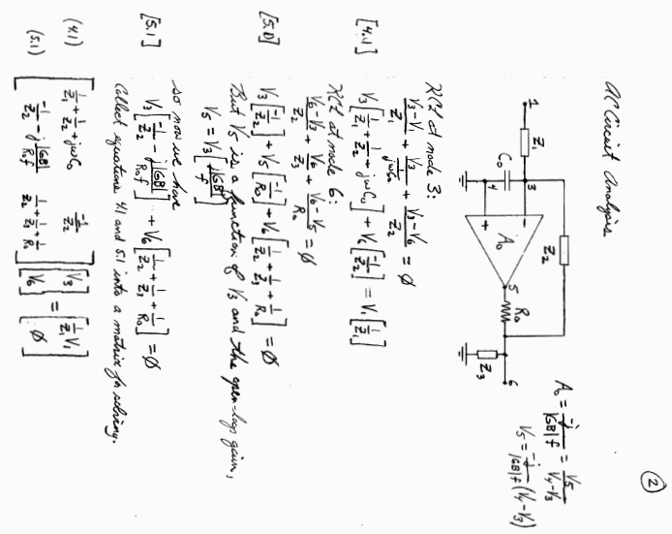

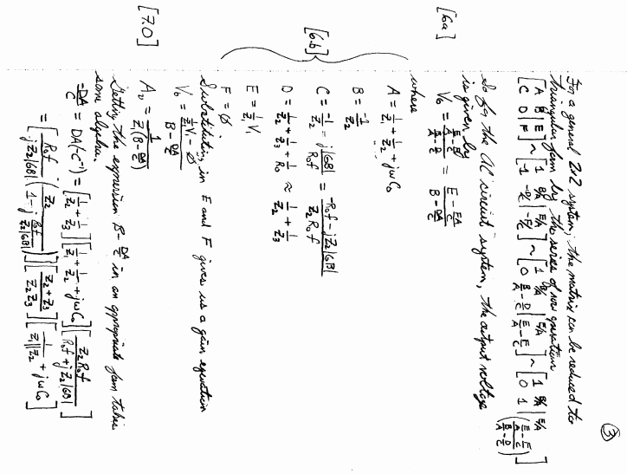

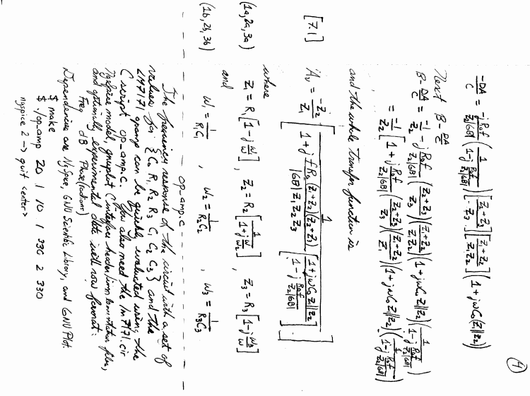

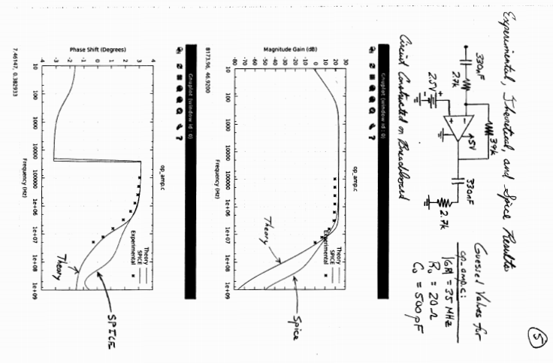

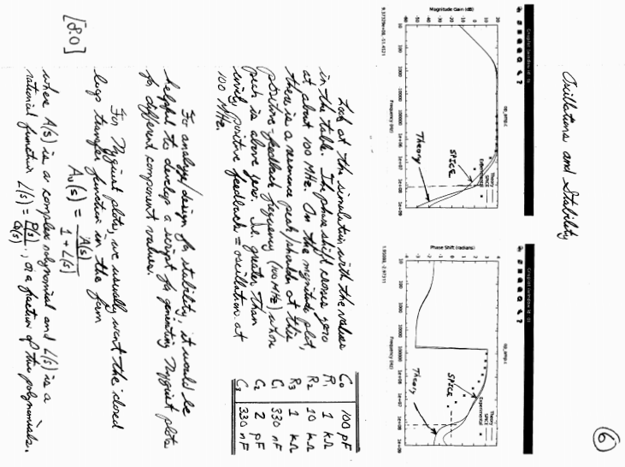

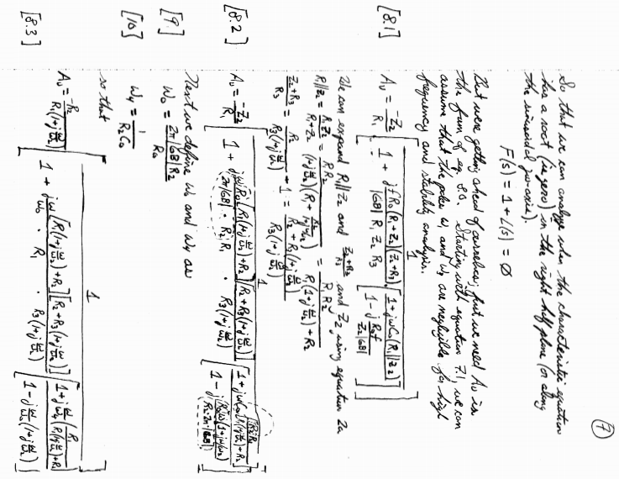

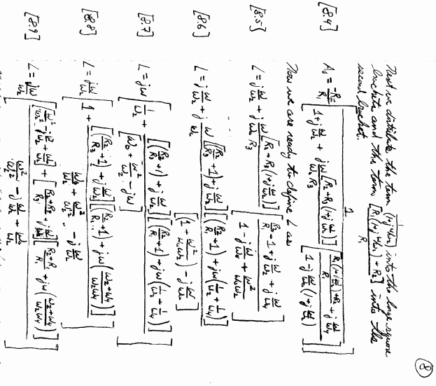

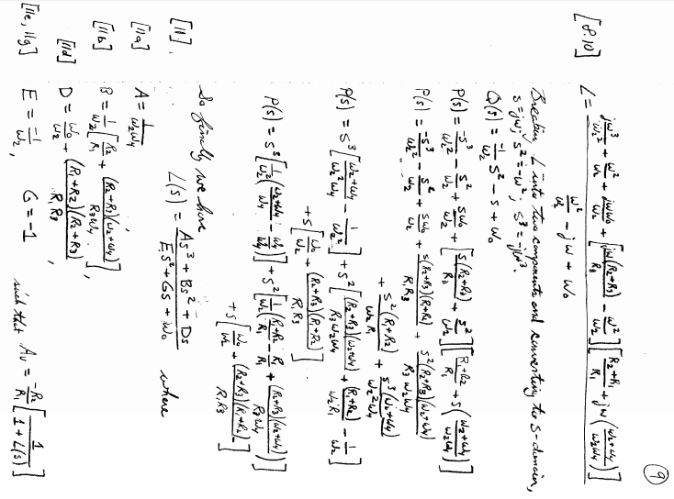

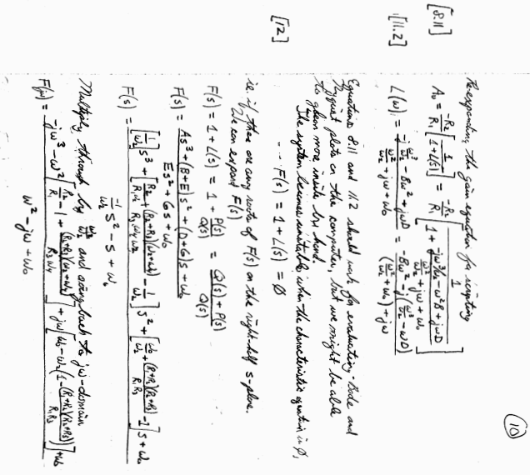

**Ethernet Code**

The following three files, Makefile, broadcast_packet.c, and ethernet_listen.c can be used to test a crossover connection between two PCs. The broadcast packet program should be run on one PC and while the Ethernet listen server is run on the other. It is also helpful to disconnect both PCs from wireless or any other networks so that the broadcast packet is not buried in a barrage of network activity.

Both programs were written using Linux sockets, so they should be compiled on Linux machines. The Makefile works to compile both programs using the GCC compiler.

To compile and run broadcast_packet.c on Ubuntu, open a terminal by pressing ctrl+alt+t and use the cd command to navigate to the directory containing both Makefile and broadcast_packet.c. Use make to compile and running the executable should give you information on other command line parameters needed.

$ cd ./directory-containting-broadcast_packet

$ make

$ sudo ./broadcast_packet.exe

The Ethernet listen program can be compiled and run similarly on the other machine. If you need to install GCC, use the command

$ sudo apt-get install gcc -y

**Ethernet Code - Makefile**

# Makefile for Ethernet Broadcast and Listen Test Programs

all: broadcast_packet ethernet_listen

#

broadcast_packet: broadcast_packet.o

gcc broadcast_packet.o -o broadcast_packet.exe

#

broadcast_packet.o: broadcast_packet.c

gcc -c broadcast_packet.c

#

ethernet_listen: ethernet_listen.o

gcc ethernet_listen.o -o ethernet_listen.exe

#

ethernet_listen.o: ethernet_listen.c

gcc -c ethernet_listen.c

#

clean:

rm ethernet_listen.o broadcast_packet.o ethernet_listen.exe broadcast_packet.exe

#

# end of Makefile

**Ethernet Code – broadcast_packet.c**

/* broadcast_packet.c

*

* Builds an 802.3 ethernet frame and then uses Linux sockets to broadcast

* this packet to all devices on the network. The user passes the data to be

* sent and the name of the ethernet interface which should be used.

*

* Use a packet analyzer like Wireshark to confirm packets are leaving the OS.

*

* Code adapted from two webpages:

* hacked10bits.blogspot.com/2011/12/sending-raw-ethernet-frames-in-6-easy.html

* aschauf.landshut.org/fh/linux/udp_vs_raw/

* and from Encyclopedia of Telecommunications Volume 9 by Froelich and Kent.

*/

#include <stdio.h>

#include <stdlib.h>

#include <string.h>

#include <arpa/inet.h> /* htons () */

#include <sys/socket.h>

#include <linux/if_packet.h>

#include <linux/if_ether.h>

#include <linux/if_arp.h>

#include <sys/ioctl.h>

union eth_frame

{

struct

{

unsigned char dest_addr[6]; /* ETH_ALEN = 6 */

unsigned char src_addr[6];

unsigned char length[2];

unsigned char data[1518 - 6 - 6 - 2 - 4];

unsigned char fcs[4]; /* see note 1 */

} field;

unsigned char buffer[1518]; /* 1518 is maximum allowed Eth frame length */

};

/* Note 1:

* An ethernet "packet" is a 5 MHz preamble + synchronization field of

* 64 bits, followed by an ethernet "frame". The higher level software

* (this program or in other cases the OS's TCP/IP stack) is responsible

* for passing a frame with the fields dest_addr, src_addr, length, and data

* complete. The ethernet hardware is then responsible for wrapping the

* supplied frame with preamble+synchronization and a frame check sequence

* that is computed in hardware.

* The frame check sequence immediately follows the last byte of data,

* however long the data may be. In the struct above, it is only located

* after a full data array for human readability.

*/

const char BROADCAST_ADDRESS[6] = {0xFF, 0xFF, 0xFF, 0xFF, 0xFF, 0xFF};

int main (int argc, char *argv[])

{

char interface_name[1000];

int interface_index;

union eth_frame frame1;

int data_length;

memset (&frame1, 0, sizeof (frame1));

/* Get Ethernet Interface Name and Data to Broadcast from User */

if (argc != 3)

{

printf ("Usage: %s <ethernet interface> <data>\n", argv[0]);

printf (" where <ethernet interface> is the human readable name of the");

printf (" sytems' ethernet.\n");

printf (" Get the name with command \"$ ifconfig | more\".\n");

printf (" <data> is a character array to be broadcast.\n");

printf (" Example:\n");

printf (" $ %s eth0 \"Hello World!\"\n", argv[0]);

exit (EXIT_FAILURE);

}

else

{

/* Copy the <ethernet interface> name provided by User */

strcpy (interface_name, argv[1]);

/* Copy the <data> provided by user into the Ethernet Frame */

strcpy (frame1.field.data, argv[2]);

data_length = strlen (argv[2]);

frame1.field.length[0] = data_length / 256; /* in Network Byte Order */

frame1.field.length[1] = data_length % 256;

}

/* Set Destination Address to Broadcast */

memcpy (frame1.field.dest_addr, BROADCAST_ADDRESS, 6);

/* Open an Ethernet Socket */

int sfd;

sfd = socket (AF_PACKET, SOCK_RAW, htons (ETH_P_ALL));

if (sfd < 0)

{

fprintf (stderr, "socket() error %d\n", sfd);

fprintf (stderr, "(try running with sudo)\n");

exit (EXIT_FAILURE);

}

/* Look Up the Ethernet Interface Index */

struct ifreq interface_req;

memset (&interface_req, 0x00, sizeof (interface_req));

strcpy (interface_req.ifr_name, interface_name);

if (ioctl (sfd, SIOCGIFINDEX, &interface_req) < 0)

{

fprintf (stderr, "ioctl(SIOCGIFINDEX) error.\n");

exit (EXIT_FAILURE);

}

interface_index = interface_req.ifr_ifindex;

/*printf ("Index of interface \"%s\": %d\n", interface_name, interface_index);

*/

/* Look Up the Source MAC Address */

unsigned char mac[ETH_ALEN];

if (ioctl (sfd, SIOCGIFHWADDR, &interface_req) < 0)

{

fprintf (stderr, "ioctl (SIOCGIFHWADDR) error.\n");

exit (EXIT_FAILURE);

}

memcpy ( (void*)mac, (void*)(interface_req.ifr_hwaddr.sa_data), ETH_ALEN);

/*printf ("Source MAC Address %d:%d:", (int) mac[0], (int) mac[1]);

printf ("%d:%d:%d:%d\n", (int)mac[2], (int)mac[3], (int)mac[4], (int)mac[5]);

*/

/* Set the Source Address */

memcpy (frame1.field.src_addr, mac, 6);

/* Prepare sockaddr_ll Structure for sendto() */

struct sockaddr_ll saddr;

saddr.sll_family = PF_PACKET; /* repitition that this is a packet socket */

saddr.sll_ifindex = interface_index;

saddr.sll_halen = ETH_ALEN; /* confirms that ethernet address are 6 bytes */

memcpy ( (void*)(saddr.sll_addr) , (void*)BROADCAST_ADDRESS, ETH_ALEN);

/* Send Packet */

int sent, f_len;

f_len = data_length + ETH_HLEN;

sent = sendto (sfd, frame1.buffer, f_len, 0, (struct sockaddr*)&saddr, sizeof(saddr));

if (sent <= 0)

{

fprintf (stderr, "sendto() fails %d\n", sent);

exit (EXIT_FAILURE);

}

if (sent != f_len)

{

fprintf (stderr, "incomplete transmission; %d of %d bytes\n", sent, f_len);

exit (EXIT_FAILURE);

}

/* Close the Socket */

close (sfd);

return EXIT_SUCCESS;

}

**Ethernet Code – ethernet_listen.c**

/* ethernet_listen.c

*

* Builds an 802.3 ethernet frame and then uses Linux sockets to broadcast

* this packet to all devices on the network. The user passes the data to be

* sent and the name of the ethernet interface which should be used.

*

*/

#include <stdio.h>

#include <stdlib.h>

#include <string.h>

#include <arpa/inet.h> /* htons () */

#include <sys/socket.h>

#include <linux/if_packet.h>

#include <linux/if_ether.h>

#include <linux/if_arp.h>

#include <sys/ioctl.h>

union eth_frame

{

struct

{

unsigned char dest_addr[6]; /* ETH_ALEN = 6 */

unsigned char src_addr[6];

unsigned char length[2];

unsigned char data[1518 - 6 - 6 - 2 - 4];

unsigned char fcs[4]; /* see note 1 */

} field;

unsigned char buffer[1518]; /* 1518 is maximum allowed Eth frame length */

};

/* Note 1:

* An ethernet "packet" is a 5 MHz preamble + synchronization field of

* 64 bits, followed by an ethernet "frame". The higher level software

* (this program or in other cases the OS's TCP/IP stack) is responsible

* for passing a frame with the fields dest_addr, src_addr, length, and data

* complete. The ethernet hardware is then responsible for wrapping the

* supplied frame with preamble+synchronization and a frame check sequence

* that is computed in hardware.

* The frame check sequence immediately follows the last byte of data,

* however long the data may be. In the struct above, it is only located

* after a full data array for human readability.

*/

char* printsafe_cpy (char*, const union eth_frame*, int);

const unsigned char BROADCAST_ADDRESS[6] = {0xFF, 0xFF, 0xFF, 0xFF, 0xFF, 0xFF};

unsigned char host_address[ETH_ALEN]; /* ETH_ALEN is 6 */

char interface_name[1000];

int interface_index;

union eth_frame frame1;

int frame_length;

int data_length;

int main (int argc, char *argv[])

{

memset (&frame1, 0, sizeof (frame1));

/* Get Ethernet Interface Name from User */

if (argc != 2)

{

printf ("Usage: %s <ethernet interface>\n", argv[0]);

printf (" where <ethernet interface> is the human readable name of the");

printf (" sytems' ethernet.\n");

printf (" Get the name with command \"$ ifconfig | more\".\n");

printf (" Example:\n");

printf (" $ %s eth0\n", argv[0]);

exit (EXIT_FAILURE);

}

/* Copy the <ethernet interface> name provided by User */

strcpy (interface_name, argv[1]);

/* Open an Ethernet Socket */

int sfd;

sfd = socket (AF_PACKET, SOCK_RAW, htons (ETH_P_ALL));

if (sfd < 0)

{

fprintf (stderr, "socket() error %d\n", sfd);

fprintf (stderr, "(try running with sudo)\n");

exit (EXIT_FAILURE);

}

/* Look Up the Ethernet Interface Index */

struct ifreq interface_req;

memset (&interface_req, 0x00, sizeof (interface_req));

strcpy (interface_req.ifr_name, interface_name);

if (ioctl (sfd, SIOCGIFINDEX, &interface_req) < 0)

{

fprintf (stderr, "ioctl(SIOCGIFINDEX) error.\n");

exit (EXIT_FAILURE);

}

interface_index = interface_req.ifr_ifindex;

/*printf ("Index of interface \"%s\": %d\n", interface_name, interface_index);

*/

/* Look Up the Source MAC Address */

if (ioctl (sfd, SIOCGIFHWADDR, &interface_req) < 0)

{

fprintf (stderr, "ioctl (SIOCGIFHWADDR) error.\n");

exit (EXIT_FAILURE);

}

memcpy ( (void*)host_address, (void*)(interface_req.ifr_hwaddr.sa_data), ETH_ALEN);

/*printf ("Source MAC Address %d:%d:", (int) mac[0], (int) mac[1]);

printf ("%d:%d:%d:%d\n", (int)mac[2], (int)mac[3], (int)mac[4], (int)mac[5]);

*/

int count = 0;

while (1)

{

int received = 0;

received = recvfrom (sfd, (void*)&frame1, ETH_FRAME_LEN, 0, NULL, NULL);

if (received < 0)

{

fprintf (stderr, "recvfrom() error %d\n", received);

exit (EXIT_FAILURE);

}

if (received == 0)

continue;

/* If received > 0, then print out the first X chars of data */

char temp[1500];

printf ("Packet (%d): %s\n", count++, printsafe_cpy (temp, &frame1, 70));

}

/* Close the Socket */

close (sfd);

return EXIT_SUCCESS;

}

char* printsafe_cpy (char *dest, const union eth_frame *frame, int max_length)

{

/* Determine Data Length to Print */

int length;

length = 256 * frame->field.length[0] + frame->field.length[1];

length = (length < 1500) ? length: 1500; /* Max 802.3 data length */

length = (length < max_length) ? length: max_length;

/* Convert all special characters to spaces */

int i;

const unsigned char *data;

data = frame->field.data;

for (i=0; i<length; i++)

{

if (0 <= data[i] && data[i] <= 32)

dest[i] = ' ';

else if (33 <= data[i] && data[i] <=126)

dest[i] = data[i];

else

dest[i] = ' ';

}

/* Null Terminate and Return ptr for fPrinting */

dest[length] = 0;

return dest;

}